Course Administration

Preface
Welcome to the Office of Antiterrorism Assistance’s Critical Infrastructure Security and Resilience (CISR) course. Please review this section prior to and throughout the delivery of this course.

Table of Contents

Preface 1
Table of Contents 1
Terminal Learning Objectives and Estimated Times 2
Course Materials 3
Curriculum Delivery Guidelines 9
Facilitator Preparation 10
Knowledge Survey 11
Pre-/Post-Course Knowledge Survey Analysis Workbook 12
Participant Critique of Training 12
Course Preparation 12
Zero Week Preparations 12
Course Preparation Checklist 22
Classroom Set-Up Checklist 23
Suggested Classroom Configurations 23
Materials and Equipment Checklist 24
Offer Cable Statement of Resource Requirements 24
Obligation of the Host Country Government 25
Resource Requirements 26
Preparation Day Checklist 26
Daily Checklists 27
Appendix A: Pre-/Post-Course Knowledge Survey: Answer Key 30
Appendix B: Using the Pre/Post-Course Knowledge Survey Analysis Excel Workbook 34
Appendix C: Jeopardy Game Answer Key 38
Appendix D: Course Materials and Equipment 44
Appendix E: Course Schedule 45

Terminal Learning Objectives and Estimated Times
The Critical Infrastructure Security and Resilience (CISR) course enables the partner nation to increase its antiterrorism capabilities by enhancing the abilities of 24 mid-level managers and officers who are or will be responsible for critical infrastructure security to develop a process to assess and mitigate vulnerabilities of critical infrastructure and plan for resilience.

The CISR course is 10 days in length and includes 17 modules:

# | Module Title | Terminal Learning Objective | Time
1 | Course Introduction | Not applicable | 2.0 hours
2 | Introduction to Critical Infrastructure Security and Resilience | Describe the importance of implementing a well-designed physical protection system for the security of critical infrastructure. | 4.0 hours
3 | Community Engagement and Human Rights | Explain the importance of community engagement and human rights in deterring terrorism. | 1.5 hours
4 | Building Community Partnerships | Explain how to build partnerships with the community to better protect critical infrastructure. | 1.0 hour
5 | Critical Infrastructure Components | Determine the components of critical infrastructure to establish the basis of a vulnerability analysis. | 4.0 hours
6 | Critical Infrastructure Assets | Analyze critical infrastructure assets in order to prioritize them for protection. | 4.0 hours
7 | Cybersecurity | Explain cyberthreats to your organization. | 2.0 hours
8 | Surveillance Awareness: What You Can Do | Explain the actions necessary to detect and report suspicious activities associated with hostile surveillance. | 1.0 hour
9 | Explosives and Critical Infrastructure | Explain the effects of explosives on critical infrastructure. | 3.5 hours
10 | Analyzing the Threat | Create a threat analysis statement for critical infrastructure. | 5.0 hours
11 | Policies and Procedures | Describe the types of policies and procedures needed for the protection of critical infrastructure. | 4.5 hours
12 | Security Force Operations | Develop a security force response plan for the protection of critical infrastructure. | 3.0 hours
13 | Security Technology | Develop a security technology plan for the protection of critical infrastructure. | 3.5 hours
14 | Security Inspection and Validation | Describe how to develop a security inspection and validation program. | 2.0 hours
15 | Operational Resilience | Describe how to apply operational resilience strategies for your country after a terrorist attack, natural disaster, or other threat. | 3.0 hours
16 | Capstone Exercise | Apply the concepts and procedures for evaluating the physical protection system of a selected critical infrastructure. | 14.5 hours
17 | Summary and Evaluation | Not applicable | 6.5 hours

Course Materials
Each facilitator must be familiar with every lesson and prepared to substitute if necessary. ATA expects all facilitators to take an active role in coaching and providing participants feedback while they work in breakout groups. Therefore, all facilitators must read the content for each module and familiarize themselves with all elements of the instructional material before the first day of class. Be thoroughly prepared for exercises, discussions, or other activities required. Review the addenda, handouts, or other job aids listed at the beginning of each module to ensure that you have received all materials or arrange to print them if they have not been included.

Course Materials | Contents
Facilitator Guide | The Facilitator Guide is organized into the following components:  - Pre-Module Information  - Instructional Modules  - PowerPoint Slides  - Module Addenda  - Handouts  - Facilitator Curriculum Delivery Guidelines (available electronically only)
Guidelines
- Facilitator Notes: Facilitator notes appear under the slides throughout each module in the course. Be sure that you review, understand, and adhere to all facilitator notes. The facilitator notes describe the key points to present from the material.
- PowerPoint Slides: PowerPoint slides are provided for facilitators and participants. You will be provided with PowerPoint slides in English. For translated materials, the PowerPoint slides presented in the classroom and included in the Participant Guide contain call-out boxes in the bottom left corner of the slide with an English translation. It is ATA’s expectation that facilitators will present the training materials as written. However, there may be unanticipated situations in which you feel the need to sidestep a particular slide or case study, to accommodate regional sensitivities or to facilitate the instruction beyond the allotted time due to unexpected constraints. In these cases, you may use your best judgment as to how to deliver the instruction, adhering as closely as possible to ATA intent.
- At the End of Training: Your copies of the Facilitator Guide materials and corresponding CDs should be left behind after completing the training. The ATA training delivery officer (TDO) will provide you with new materials for each training iteration to ensure that you are using the most current version. You should give everything to the regional security officer (RSO) or, with his/her concurrence, to the local point of contact at the partner nation’s training venue, or to participants who were identified as future trainers for the course.
Course Materials | Contents
Participant Guide | The Participant Guide is organized into the following components:  - Pre-Module Information (includes table of contents and course administration)  - Module Introduction (contains key terms and abbreviations/acronyms and module equipment list)  - PowerPoint Slides (in print form with notes section)  - Module Addenda (sequentially numbered in the order referred to in the facilitator notes of the Facilitator Guide)
Guidelines:
- ATA provides all participants with a Participant Guide translated into their own language or dialect.
- The content of the instructional modules in the Participant Guide includes:
- The module introduction (i.e., the first two pages of the module).
- The PowerPoint slides in three-per-page handout format.
- The module addenda. The Participant Guide contains all addenda that are relevant to participant instruction, lettered consecutively.
- You should be familiar with the organization and structure of the Participant Guide. Distribute the Participant Guides in the classroom prior to participants' arrival.
- DO NOT DISTRIBUTE THE PARTICIPANT CDs UNTIL THE CONCLUSION OF THE TRAINING. The participant CDs contain a translated copy of the Facilitator Guide and all associated materials. We do this hoping the participants will share the knowledge they gain with their colleagues and use it for training in their own academies.

Use of Icons
The following symbols will appear in the upper right corner of PowerPoint slides and in the Facilitator Guide.

Icon | Name | Description
 | Addendum | Purpose: Module addenda include job aids, checklists, practical exercises, and sample forms. It is important to know when to refer the participants to an addendum and to help them locate the materials.  Course Materials: Addenda appear in both the Participant and Facilitator Guides after the PowerPoint slide.
 | Handout | Purpose: Handouts are used when the information cannot be placed in an addendum.  Course Materials:  - Handouts appear in the Facilitator Guide following the addenda.  - Standard handouts in all courses include:  - Pre- and post-course knowledge surveys  - Participant critique of training  - Facilitators receive shrink-wrapped copies of translated handouts.  - Facilitators should organize the handouts and be ready to distribute them at the appropriate time.
 | Handbook | Purpose: ATA may add a handbook to a course when there are comprehensive exercises, such as capstone exercises, multiple outdoor practical exercises, or in-depth threaded case studies. Facilitators should be familiar with the information in the handbook.  Course Materials:  - Handbooks are in a separate folder on the facilitator CD.  - Facilitators receive copies of translated handbooks.  - Facilitators must be prepared to distribute handbooks at the appropriate time.
 | Human Rights and Community Engagement | Purpose: ATA has a commitment to preventing violent extremism by emphasizing the importance of community and human rights throughout the training. This icon indicates an opportunity for facilitators to foster a dialogue about the benefits of promoting human rights in the conduct of the participants’ daily job functions.  Course Materials: This icon appears in the Facilitator Guide and on the accompanying slides.
 | Video/Animation | Purpose: Videos or animations on a PowerPoint slide illustrate key course concepts. Make sure to test and preview all media elements before presenting a module.  Course Materials: This icon appears in the Facilitator Guide and on the accompanying slides.
 | TeachBack | Purpose: A TeachBack is a way to confirm that participants have learned a certain concept by asking them to explain the content in their own words to the facilitator. TeachBack moments have been integrated throughout the course, and generally will occur immediately before the closing summaries of the modules in which they appear. This type of exercise provides participants with an opportunity to recall what they learned and practice their public speaking skills.  Course Materials: This icon appears in the Facilitator Guide and on the accompanying slides (if appropriate).

Module Introductions
Module Key Elements: Each module within the Facilitator Guide and Participant Guide begins with a cover page that lists the following critical information about the module:

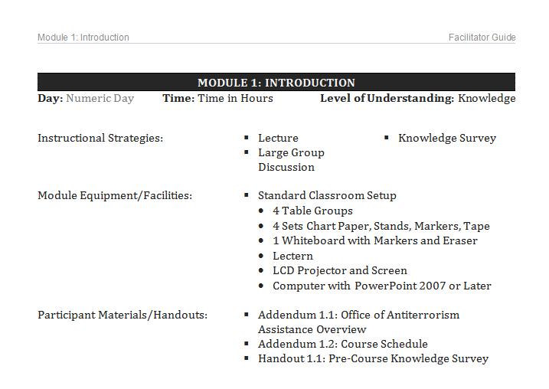

Use this information to prepare to facilitate the module and orient the course participants.

Topics Map: Within the introduction pages, a chart lists each topic contained in the module, corresponding enabling learning objectives, and approximate time.

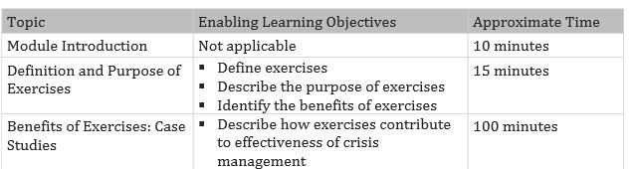

Use these topic charts to plan facilitator assignments, understand the flow of the module, and manage the pace of the module. Multiple facilitators may instruct topics within the longer modules. All facilitators need to support activities conducted in breakout groups.

Note that module times are guidelines only. The actual time required may vary based on the experience level and interest of the participants or other factors encountered during the training session.

Key Terms and Abbreviations/Acronyms: The module introduction also includes charts with key terms, abbreviations, and acronyms.

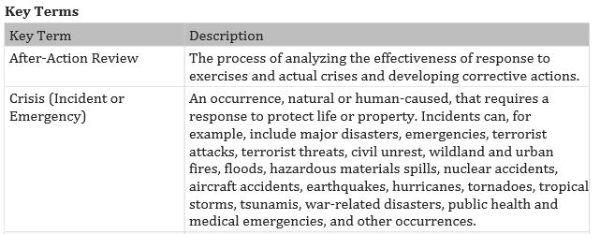

At the beginning of each module, take time to direct the participants to the location of the key terms, abbreviations, and acronyms. Because the module often teaches the terms and concepts in these charts, avoid teaching the information. Rather, ensure that participants know where to find the information.

Curriculum Delivery Guidelines
Facilitators should remember that they are in-country on official business for the United States government and should conduct themselves as such at all times. Remember, this may be the first contact for many of the participants with someone they perceive as an official representative of the US government, and your actions will have consequences long after your departure. Be professional, open minded, welcoming, and accessible to all those you deal with, and your legacy will be greater understanding and improved cooperation with our mission personnel.

The Curriculum Delivery Guidelines document is located on the facilitator CD only (LEAD folder) and is not printed in the Facilitator Guide. These guidelines encompass a range of topics designed to enable the effective presentation of the ATA course materials.

Discussion topics include the following:
- Curriculum development
- Adult learning principles
- Communication skills and styles
- ATA assessment instruments
- ATA course development model
- Facilitation of small-group activities
- Collaborating with an interpreter
- Other facilitation tips and tools

It is important that you become familiar with these curriculum delivery guidelines before teaching this course.

Facilitator Preparation
- Work with your co-facilitators to plan a teaching strategy.
- Remember that all facilitators should stay in the classroom as much as possible during the module presentations. This allows the participants to benefit from the mix of facilitator expertise.
- Follow along while the other facilitators are presenting and help answer questions, provide examples, or relate the content to the participants.
- Provide coaching by working directly with participants throughout small-group activities.
- Prepare to teach the modules for which you are the lead presenter.
- Understand how your modules relate to the course as a whole and be prepared to serve as substitute facilitator, if necessary.
- Familiarize yourself with each module’s objectives, topics, addendums, handouts, and guidance in the facilitator notes. The PowerPoint slides are intended to supplement the lesson plan but not to replace it. Facilitators must follow the lesson plan and not rely solely upon the PowerPoint slides to teach the course.
- Prepare to conduct all activities and encourage interaction. The course is intended to be collaborative, with frequent feedback from participants.
- Arrange the classroom.
- Account for all course materials shipped from ATA and provided by post.
- Check that the classroom is set up in accordance with this administrative module.
- Arrange the Participant Guides on the classroom tables before the participants arrive on Day 1 of the course. Do not distribute the course materials compact discs until the end of the course.
- If name tents showing the participants’ names and organizations have not been provided, coordinate with your point of contact at the training site or with the regional security officer (RSO) to have some made. Ensure the correct spelling of all names.

Knowledge Survey
Purpose: Surveying participants is one way to determine the quality and applicability of a course and to ensure that it provides participants with the knowledge and skills they need. The knowledge survey is not a measurement of abilities or intelligence. The survey is intended to be used for internal purposes only and no one outside the ATA staff will have access to this data. Participants are not required to put their names on the surveys. Furthermore, only the facilitator and ATA staff will see individual results.

Materials: Both the pre- and post-course knowledge surveys (which have identical questions) are shrink-wrapped and provided as handouts for the participants. The pre-course knowledge survey is located behind the PowerPoint slides in Module 1: Course Introduction of the Facilitator Guide. The post-course knowledge survey is located behind the PowerPoint slides in the Summary and Evaluation module of the Facilitator Guide. The answer key for the pre- and post-course knowledge surveys is located in Appendix A of Module 0.

Administering the Survey: When administering the survey, explain to the participants that no grade is attached to the survey. You will administer the knowledge survey twice during the course: (1) as a pre-course knowledge survey and (2) as a post-course knowledge survey. The surveys consist of multiple-choice questions derived from instruction and practice presented within the modules.

You will administer the pre-course knowledge survey at the end of Module 1: Course Introduction to estimate the level of knowledge participants have when entering the course.

Upon completion of the course, you will administer the same survey as a post-course knowledge survey. This second survey will include identical multiple-choice questions.

Reporting: The lead facilitator will report the data from the pre-course knowledge survey and post-course knowledge survey in the End-of-Course Report. The completed pre- and post-course knowledge surveys must be mailed back by the lead facilitator to the respective ATA training delivery officer at the end of the course. The LEAD folder on the facilitator CD contains information on how to complete the End-of-Course Report.

The results will provide ATA with a scientific method of assessing the course. ATA can examine how programs (individually and collectively) are meeting the Department of State’s expectations for participant learning and development. Evaluation and corrective actions also allow ATA to continually improve the training material. It is this assessment process that identifies each program's contributions to participant growth and determines ATA’s overall effectiveness in helping other nations in their fight against terrorism.

Pre-/Post-Course Knowledge Survey Analysis Workbook
Located within the LEAD folder on the facilitator CD is the Pre-/Post-Course Knowledge Survey Analysis workbook, which must be completed and provided electronically to the ATA training delivery officer (TDO) following completion of the course delivery.

The Pre-/Post-Course Knowledge Survey Analysis workbook is a Microsoft Excel product (see Appendix B) intended to benefit both course facilitators and the Training Curriculum Division of ATA.
- There is no longer a need for facilitators to “grade” tests, because entering the answers selected by participants automatically scores all tests and completes the calculations as they are entered by the facilitator.
- Facilitators can refer to the “Summary” and “Statistics” tabs after entering the pre-course knowledge survey answers as a means of identifying areas where participants may be weak or have existing knowledge. This can help the instructor team plan how to use available training hours most efficiently so as to maximize learning.
- The completed workbook is emailed to the TDO electronically by the Lead Facilitator, as is the After-Action-Report. Note: Original copies of the pre/post surveys must continue to be forwarded to the TDO to comply with Federal regulations.
- Statistical information contained in the workbook is uploaded electronically into the course evaluation database maintained by ATA for comparative analysis.

Participant Critique of Training
The participant critique of training is a way that ATA evaluates the degree of their success in delivering training. The critique form will ask participants for ideas about how the course could be improved and how much they feel they have learned. Stress again that this is not a test of ability; rather, it is a method to request a range of opinions on how ATA can improve the course.

Course Preparation

Zero Week Preparations
- Prior to your arrival in-country, the host country government should have selected 4 possible sites that you will evaluate during your preparation week. After visiting these sites with the host country representative, you will select two sites to use in the capstone exercise (starting on Day 8).
- The RSO/representative will have been informed that this requirement is critical to the success of the course and that the ability to conduct this exercise outside the training facility offers participants the chance to perform in a realistic environment.
- It is the responsibility of the Host Country Government in coordination with the RSO to locate and propose the site(s), secure permission to conduct training at the site(s), and coordinate a site visit for you to examine the site(s) during Zero Week. You are responsible for visiting the site(s), meeting with the site(s) point-of-contact, and gathering the information participants will need to complete the capstone exercise.
Site Advance Instructions
- During your initial visit to the site(s), you must complete Table 1: Facilitator Site Survey Checklist for each location. This will ensure you have gathered all the information needed to complete the preliminary Table 2: Site Survey Reports. Remember you must evaluate all four sites selected for the capstone exercise. You should familiarize yourself thoroughly with each site, take photos, and complete the checklist for each site. Once you have seen all the proposed sites as a facilitator team, select the two sites most conducive to conducting the capstone exercise. Note that none of the selected sites should be further than 30 minutes away from the primary training facility.
- After visiting the sites, complete Table 2: Site Survey Report, Table 3: National Protective Intelligence Report, and Table 4: Detailed National Protective Intelligence Report for each location. You must also complete an intelligence report based on the specific threat information for each site. Note: this MUST include a bomb threat so participants can complete the standoff distance calculations.
- You will complete both an Intelligence Report and a Detailed Intelligence Report for the Site — a document similarly formatted to the Site Survey Report. Ensure that your exercise scenario includes a bomb threat so that participants will be required to calculate blast distances. These documents are vital to the capstone exercise. You will provide this report information verbally at the appropriate times throughout the exercise.
- When possible, use real threat information from the host nation. This will add increased realism to the exercise and be more valuable to the participants. If this is not feasible or practical, you may use the proposed scenarios below.
- To complete Table 3: National Protective Intelligence Report 1:
- Use the forms below to document possible goals and intent of group at site.
- Develop a list of various sites that have been targeted previously in the region.
- Write down types of weapons that have been used previously in the region.
- Write down types of criminal activity in the area that may be suspicious and applicable to the critical infrastructure.
- Create any indication of current surveillance discovered in the area.
- Document any specific threats to the facility.
- If no threat data is available, you may tailor the scenarios below.
- To complete Table 4: National Protective Intelligence Report 2:
- Document the type of explosive relevant to the region.
- Identify the amount of explosives reported by sources.
- Create history of explosives with this group.
- Document the possible use of this explosive (for example, VBIED, IED).
- If no threat data is available, facilitators may use the scenarios in Table 5: Intelligence Report 1 and Table 6: Intelligence Report 2.

Table 1: Facilitator Site Survey Checklist (Make one copy per site visited)
 | Information Needs | Notes
 | Facility Title and Local Name
 | Facility Location
 | Facility Description
 | Facility Contacts for Approval of Exercise
 | Facility Tour
 | Facility Layout
 | Facility History
 | Area Crime Types and Levels
 | Facility Construction Type
 | Facility Entrances and Exits
 | Streets that Give Facility Access
 | Types of People that use the Facility
 | Facility General Safety
 | Facility Fire Safety
 | Money Management on Site
 | Assets on Site
 | Facility External Barriers or Fences
 | Facility Hours of Operation
 | Current Security Operations
 | Current Technology Security Measures
 | Current Security Policies and Procedures Used
 | Current Security Force On-Site
 | Previous History with VIPs
 | Other Security Threats in Close Proximity
 | Insider Threat Notes

Table 2: Site Survey Report
Site Survey Report
Site Name
Site Location
Site Description
Site Contacts
Site Layout
General Information
Physical Data/Conditions

Site Operations
Policies and Procedures
Existing Security
Regulatory Requirements
Safety
Legal Considerations
Additional Information of Interest to Participants

Table 3: National Protective Intelligence Report
Goals and Intent of Group at Site
List of Sites That Have Been Targeted Previously in the Region
Types of Weapons That Have Been Used Previously in the Region
Types of Criminal Activity in the Area
Current Surveillance Discovered in the Area
Specific Threats to the Facility
Table 4: Detailed National Protective Intelligence Report
Type of Explosive
Amount of Explosives Reported by Sources
History of Explosives with this Group
How They May Use the Explosives

If no threat information is available, facilitators may choose to use the following scenarios.

Table 5: Intelligence Report 1
Your country borders the nation of Freedonia. The government of Freedonia has little control over the country. A large, capable extremist group, the Freedonia Separatists, threatens to take over the country. The group has also conducted several terrorist attacks.
These attacks included a vehicle bomb using a small stolen compact passenger vehicle, which destroyed the front of one of the bordering countries government buildings, and two computer system intrusion attempts into the Freedonia national banking system personnel files that intrusion detection software reported. The intrusions were not successful.
The Freedonia Separatists have publicly stated that they will attack countries in the region that do not recognize them as the official government of Freedonia.

Table 6: Intelligence Report 2
Intelligence sources have indicated that the Freedonia Separatists have a quantity of explosives that they are planning to use soon.
Information about the current situation and the group’s history is in the table below.
Type of Explosive | TNT
Amount of Explosives Reported by Sources | A large quantity of explosives, estimated to be approximately 450 kilos of TNT along with electric detonators, was stolen from a military camp.
History of Explosives with this Group | In the recent past the Freedonia Separatists have conducted two vehicle bombings using stolen compact passenger vehicles parked in general public access areas. Both devices used homemade explosives. One failed to detonate and the other was successful. Both attacks were directed at government facilities in public access areas. Additional unsupported intelligence indicates the Freedonia Separatists have attempted to recruit suicide bombers.
How They May Use the Explosives | Based on history, the most likely method of attack will be a vehicle bomb parked in a public access area.

Course Preparation Checklist
The Course Preparation Checklist below outlines the various tasks and training concerns you must address for successful presentation of the course.

Arrival In-Country
Meet with the Regional Security Officer (RSO) or Designee
Confirm training location
Confirm arrival of training equipment
Determine site visit locations and visit times
Identify location, distribution, and storage of equipment
Identify transportation for facilitators
Produce a phone list of:
- RSO or designee
- In-country point of contact (POC)
- US Embassy
- US Marine Security Detachment
- Other
Collect participant info:
- Roster
- Vetting confirmation
- Arrangements for meals and snacks (tea or coffee breaks)
- Designated participant spokesperson
Information provided by RSO or designee:
- Security briefing
- Embassy hours
- Check cashing policy
- Commissary (Does embassy have one? Can team use it?)
- APO/FPO address (Does embassy have one? Can team use it?)
- Medical, dental facilities
- Information on opening ceremonies, special after-hours events, and graduation
- Dress code for facilitators and participants

Preparing at the Training Facility
Time the travel from the facilitator housing to the training facility
Ensure timely access to the training facility for purposes of preparing the classroom in advance of the course
Establish training day and break schedule based on in-country constraints
Lead facilitator ensures that classroom is properly set up

Classroom Set-Up Checklist
Classroom (confirm/identify the following)
Location of facility
Size
Number of seats
Configuration of tables
Electricity (standard, generator)
Outlet type
Air conditioning or heat, as appropriate
Computer
Screen and projector
Equipment

Suggested Classroom Configurations
During the CISR course, participants work in teams throughout the training. Whenever feasible, configure the classroom with four table groups as shown below.

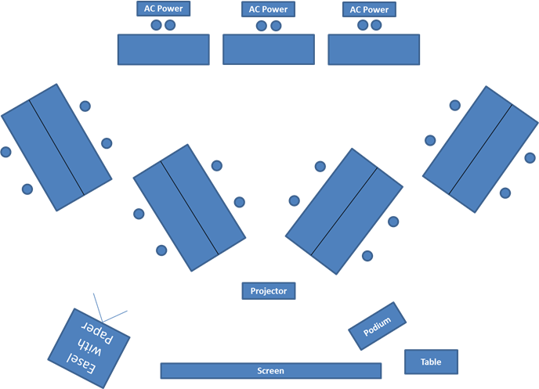

Although the course offer cable requests a classroom space to facilitate this training configuration, local conditions may not be able to accommodate the recommended room setup.

Materials and Equipment Checklist
Materials and Equipment
Inventory all participant materials and ensure all handouts (pre- and post-course knowledge surveys and participant critique of training) were included
Test all equipment (laptop, projector, laser pointer)
Inventory required equipment
Familiarize yourself with the equipment by reviewing the operating manuals for each type of equipment; facilitator instructions in the module are general enough to allow for modification, depending on the type of equipment provided
Test all equipment and place equipment on chargers
Ensure Microsoft Office is installed on all laptops or tablets and load the Participant Briefing Template from the Lead Folder on the Facilitator CD on all participant laptops or tablets.

Offer Cable Statement of Resource Requirements
Post or the Government must provide or arrange for the following:
- Classroom facility that meets the following requirements:
- Accommodates 24 participants, 4 instructors, and several observers
- Configured in four table groups
- Adjustable lights to facilitate use of projection equipment and to enable course participants to read course materials and take notes
- Secures overnight (course materials will be stored in the room and must be safeguarded)
- Space, power, and air conditioning to support computer equipment, projectors, and audio equipment
- Internet access, if available, and power for instructors’ personal computers
- Four laptop computers with SD card reader capabilities, USB ports, basic Microsoft Office capabilities, and local language keyboard capabilities
- Separate room for the exclusive use of the instructor staff. Internet access is strongly preferred
- Large screen or wall suitable for projecting PowerPoint presentations
- Two power transformers
- Surge protector/power strip
- Three-hole paper punch
- Four flip-chart easel/dry erase board combo with erasers
- Six flip-chart paper pads
- 12 dry erase markers
- 12 permanent markers
- 36 AA batteries
- Six 9-volt batteries
- 40 writing tablets
- 40 pencils
- 40 pens
- 40 binder clips, small
- 40 binder clips, medium
- Two staplers and one box of staples
- Six post-it notepads, standard size
- 25 Manila envelopes, letter size
- Six manual pencil sharpeners
- One UPS battery backup system
- Two packs of push pins (tacks)
- Two extension cords, 25’ – 50’
- Three rolls of duct tape
- 12 disposable dispensers of scotch tape
- 25 highlighters
- One podium and flat utility table to accommodate a laptop computer and projector
- Two handheld and two lapel wireless microphones
- Four cell phones or cell phone cards for instructors for official use only
- Transportation for instructor team during its stay; please note that the instructors bring some equipment, so a van is usually required for transportation.
- Additional transportation needed for day 8 of the training to transport two groups of 16 to the two sites to conduct the exercise

Obligation of the Host Country Government
As part of the training, participants should have the opportunity to conduct a vulnerability analysis on a critical infrastructure site. These sites include any location that provides a reliable flow of products and services essential to the defense and economic security of the nation, to include communications, power and electric, gas and oil, industry, water, banking and financial, education, government, transportation, emergency services, foreign-represented governments, and recreational venues. Prior to instructor team’s arrival, ATA requests that the partner nation point of contact identify four critical infrastructure sites from which the instructor team can select two that best fulfill the training objectives. The sites should be no more than a 30-minute drive from the training classroom.

The instructor team requires three business days prior to the course start date to visit the four preselected sites with a designated point of contact from the host government or post. During the one-day field exercise, instructors request a point of contact at both sites to meet and escort 12 participants and two instructors which should be from three to five hours.

Resource Requirements
In order to accomplish the training objectives, the selected training location needs to be within 30 minutes travel time to the venues selected for the practical field exercise. This course can be delivered at a partner nation’s training academy or at a host country hotel, where the classroom portion will be conducted in a conference room and many of the practical exercises conducted on the hotel grounds. If the decision is to conduct the course at a hotel, the hotel should be the same one where the facilitators will be lodged.

Preparation Day Checklist
Preparation Day
Locate the four Facilitator Guide sets.
- Provide one copy to each facilitator with his/her name on it.
- One copy may need to be provided for the interpreter. If so, determine how the facilitator team will share the remaining copies.
Review the handouts.
- Check that they have all been printed and are in the proper language.
- Put them in order and in a box for easy dispersal.
Secure the pre-/post-course knowledge surveys, participant critiques of training, completion certificates, and participant course materials CD.
Set up the classroom chairs in table groups or a U-shape.
Move a table in front of the room for props.
Place the Participant Guide at each seat (shipped from ATA). Check the language.
Place a pen and notepad at each seat. Pads may have to come from the RSO.
Set up the projector and computer. Check if they work. Tape the cords to prevent tripping.
Place two easels with chart pads and markers in the front of the room.
Write the class name, number, facilitators, ATA Representative, interpreters, etc. on chart paper.
Account for all inventory using the equipment list at the end of this document.
Obtain the following materials and bring them to the classroom:
- Adapters
- Chart paper pads and stands
- Markers
- Name tents
- One first aid kit
- Paper towels
- Pens/pads (Pads are not always provided. Check with the ATA Representative.)
- Power converters
- Printer, paper, USB cables (if feasible)
- Sanitizer
- Surge protectors
- Tape – masking and cellophane
Prepare for Module 1 (next day):
- Locate Handout 1.1: Pre-Course Knowledge Survey.
- Ensure that the name tents are ready.
- Determine an appropriate location for the class photo.
Prepare for Module 2: Introduction to Critical Infrastructure Security and Resilience

Daily Checklists
Day 1
Conduct Module 1.
- Have the participants checked against the vetted participant list (preferably done by the Embassy or ATA Representative).
- Make name tents (including rank and name to be used in class) and tape them down for each participant. Use the markers and tents secured during the preparation day.
- Obtain the names of attending officials at the opening ceremonies (for the Opening Day Report).
- Obtain the departments represented (for the Opening Day Report).
- Work with the interpreters and a staff facilitator to write participant expectations on chart paper as they introduce themselves.
- Name the class lead and provide him/her with the contact list.
- Administer the pre-course knowledge survey.
- See Module 0: Appendix A for answer key.
- Class photo — assign a facilitator to find the location, set up the camera, and take the class photo (see Preparation Day checklist).
Conduct modules in accordance with the course schedule.
Prepare for Module 3: Community Engagement and Human Rights (next day).
Prepare for Module 4: Building Community Partnerships (next day).
Prepare for Module 5: Critical Infrastructure Components (next day).
- Gather the component evaluation information from the host facility and the methodology you use to obtain the information to share in the module presentation.
- In the event you are not able to gather information about the host facility, describe how you would have applied the recommended methodology stages and what information you would have gathered, specific to the host facility.

Day 2
Conduct modules in accordance with the course schedule.
Prepare for Module 6: Critical Infrastructure Assets (next day).
Prepare for Module 7: Cybersecurity (next day).
Prepare for Module 8: Surveillance Awareness: What You Can Do (next day).

Day 3
Conduct modules in accordance with the course schedule.
Prepare for Module 9: Explosives and Critical Infrastructure (next day).
Prepare for Module 10: Analyzing the Threat (next day).

Day 4
Conduct modules in accordance with the course schedule.
Prepare for continuation of Module 10: Analyzing the Threat (next day).
Prepare for Module 11: Policies and Procedures (next day).

Day 5
Conduct modules in accordance with the course schedule.
Prepare for Module 12: Security Force Operations (next day).
Prepare for Module 13: Security Technology (next day).

Day 6
Conduct modules in accordance with the course schedule.
Prepare for Module 14: Security Inspection and Validation (next day).
Prepare for Module 15: Operational Resiliency (next day).
Prepare for Module 16: Capstone Exercise (next day).
- Confirm all travel arrangements so that the participants, facilitators, and interpreters (if applicable) can travel to and from the selected sites
- Ensure all laptops are operational, loaded with the Microsoft Office Suite, and that the Capstone Exercise Presentation Template is loaded on every machine
- Ensure that all site advance activities identified in the Site Survey section are completed. Facilitators must complete the Site Survey Reports and Intelligence Reports before beginning this module.

Day 7
Conduct modules in accordance with the course schedule.
Prepare for continuation of Module 16: Capstone Exercise (next day).

Day 8
Conduct modules in accordance with the course schedule.
Prepare for continuation of Module 16: Capstone Exercise (next day).

Day 9
Conduct modules in accordance with the course schedule.
Prepare for Module 17: Summary and Evaluation (next day)
- Confirm schedule for commencement.
- Confirm certificates are available for commencement.
- Locate all handouts and Jeopardy Game needed for module.

Day 10 [FINAL DAY]
Conduct Summary and Evaluation Module:
- Complete course review and module summaries.
- Use Jeopardy Game PPT in LEAD folder for review.
- Administer the post-course knowledge survey.
- See Module 0: Appendix A for answer key.
- Explain and allow time to complete the participant critique of training.
- Distribute the contact sheet and participant CDs.
- Conduct the commencement ceremony.
Thank the participants for their participation and conclude the course.

Appendix A: Pre-/Post-Course Knowledge Survey: Answer Key
Select the best response to each question by drawing a circle around the letter corresponding to the response.

- An assessment of a given critical infrastructure consists of ________________. (Module 5, Objective 1, Slide 6)
- An appraisal of daily reports
- The efficiency of the personnel at the facility
- The evaluation of functional components
- The frequency of equipment maintenance

- When an adversary is trying to penetrate or attack a critical infrastructure, the first two functions of a physical protection system include detection and delay. What is the third function of a physical protection system? (Module 2, Objective 4, Slide 51)
- Threat analysis
- Response
- Security inspection
- After-actions reporting

- Which of the following are examples of critical assets? (Module 2, Objective 3, Slide 20)
- People, information
- Equipment, competitors
- Processes, currency
- Data, stocks

- During a critical infrastructure assessment, a “data call” refers to: (Module 5, Objective 2, Slide 33)
- Scheduling a visit to the site
- Conducting a visit to the site
- Analyzing the information gathered during the site visit
- Requesting information about the site prior to the site visit

- When law enforcement agencies and the community and organizations they serve work together for the purpose of developing solutions to problems and increasing trust in law enforcement, it is known as community _____________________. (Module 4, Objective 2, Slide 11)
- Alliance
- Cooperation
- Affiliation
- Partnership

- Identifying all _________________ is necessary before conducting an asset analysis. (Module 6, Objective 1, Slide 8)
- Hostile surveillants
- Critical assets
- Potential threats
- Undesirable consequences

- Since it is not possible or practical to protect all critical infrastructure assets, you must: (Module 6, Objective 2, Slide 11)
- Ensure continuity of services by protecting government operations to guarantee security of civilian assets
- Provide protection for critical infrastructure first, then soft targets second
- Protect your facilities before information and equipment
- Prioritize protection for assets according to their importance

- Which of the following is any circumstance or event with the potential to adversely affect an information system via unauthorized access, destruction, disclosure, modification of information, or denial of service? (Module 7, Objective 1, Slide 3)
- Cyberinfrastructure
- Cyberinterdependency
- Cyberthreat
- Cybersecurity

- Robustness, resourcefulness, and rapid recovery are the three elements of ______________________ in your cybersecurity policies and procedures? (Module 7, Objective 3, Slide 25)
- Critical asset planning
- Resilience planning
- Physical protection system
- Gap analysis

- As terrorist organizations prepare to launch an attack against a critical infrastructure site, ___________________ can be the weak link in their preparation process. (Module 8, Objective 4, Slide 15)
- Scope
- Security system tests
- Surveillance
- Acquisition of supplies

- A person is observed on repeated occasions taking several quick photos of a critical infrastructure with a cell phone from several locations. This is an example of _____________________ that can indicate hostile surveillance. (Module 8, Objective 4, Slide 18)
- Normal behavior
- Unusual activities
- Surveillance detection
- Reporting actions

- Which type of improvised explosive device currently poses the most destructive threat to a critical infrastructure? (Module 9, Objective 2, Slide 38)
- Pipe bomb
- Grenade
- Large vehicle bomb
- Letter bomb

- Which of the following is the most effective security measure against a vehicle-borne improvised explosive device? (Module 9, Objective 2, Slide 38)
- Distance
- Reinforced structures
- Early detection
- Evacuation

- The overall purpose of a threat analysis statement is to: (Module 10, Objective 1, Slide 4)
- Collect historical data about insiders who posed threats to the facility in the past
- Gather intelligence information on one or more threats
- Evaluate the security technology for a specific facility
- Determine if there are existing policies and procedures for a specific facility
- The purpose of written procedures pertaining to critical infrastructure security is to: (Module 11, Objective 1, Slide 8)
- Replace the need for direct supervision by management
- Explain what the organization does operationally
- Explain the organization’s position regarding security plans
- Provide consistent security force response

- A process in which an alarm sensor activates due to an intrusion, a nuisance alarm, or false alarm is called: (Module 12, Objective 1, Slide 4)
- Assessment
- Delay
- Security force response
- Detection

- The four primary elements that contribute to the effectiveness of a security force include: selection of security force members, initial and continuous training, deployment of adequate equipment, and ___________. (Module 12, Objective 2, Slide 44)
- Extensive bomb crisis management experience
- Thorough knowledge of blast effects of explosives
- Appropriate supervision
- Specific training on the most current security technology

- A passive sensor is typically one that: (Module 13, Objective 2, Slide 13)
- Is normally attached to the wall
- Detects some type of energy emitted by the intruder
- Is visible and therefore easy to defeat
- Transmits energy and detects a change in received energy

- During ___________________ of the security inspection and validation program, you identify assets associated with the critical infrastructure. (Module 14, Objective 3, Slide 23)
- Phase 1: Inspection planning
- Phase 2: Conducting the inspection
- Phase 3: Asset evaluation
- Phase 4: Close-out

- Which step of the gap analysis process determines what areas (risks) do not meet the pre-established performance standards or expectations? (Module 15, Objective 3, Slide 25)
- Step 1: Determine requirements
- Step 2: Assess existing performance levels
- Step 3: Identify gaps
- Step 4: Define risk management plan

Appendix B: Using the Pre/Post-Course Knowledge Survey Analysis Excel Workbook
The following step-action guide supplements the workbook instructions and will guide you through the process of completing the Pre-/Post-Course Knowledge Survey Analysis workbook.

Step 1

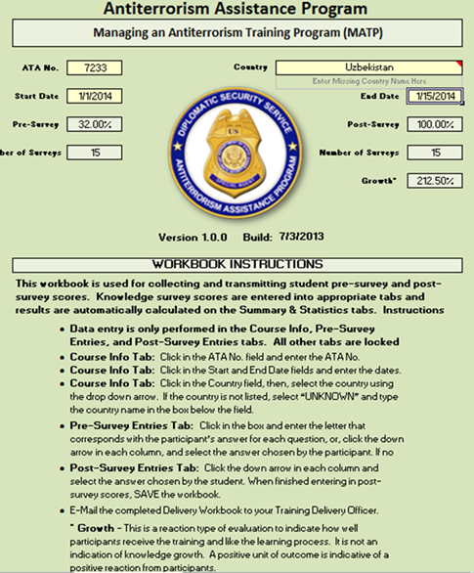 | - The Pre-/Post-Course Knowledge Survey Analysis workbook is found in the LEAD folder on the facilitator CD.  - Copy and save the program to your computer hard drive.  - When the workbook is opened, you should see the Course Info tab worksheet displayed.  - Instructions for completing the workbook are shown at the bottom of this page.

Step 2

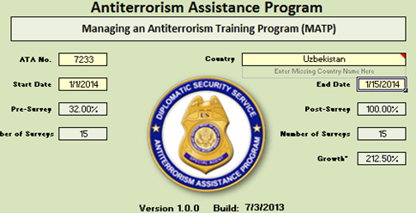 | - Enter the ATA number and the course start and end dates in the off-colored cells.

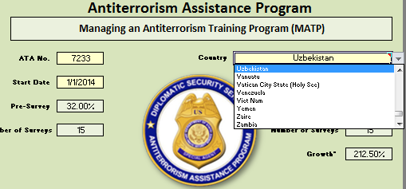 | - The Country cell has a drop-down list of current countries where ATA provides training.  - Select the country from this list for spelling consistency.

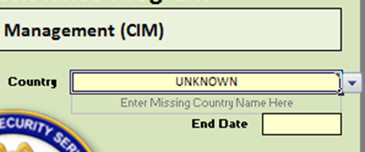 | - If the country is not on the list, type the name of the country in the box directly below the Country field.  - Save the workbook to your hard drive.

Step 3

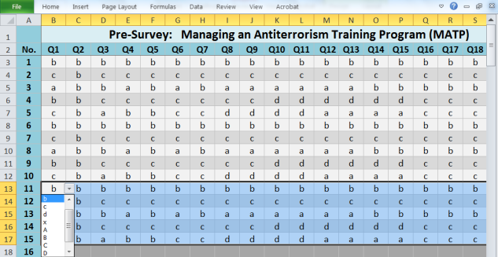 | - Select the Pre-Survey Entries tab at the bottom of the workbook screen.  - Enter the answers as they appear on the individual pre-course knowledge survey, starting with Survey No. 1, question 1.  - Note: You may type the letter (fastest) or use the drop-down box.  - Entries are not case sensitive. If you type an invalid entry, the program will alert you.  - If no answer is selected, or if multiple answers are selected, enter the letter "x" in the cell.  - Save the workbook to your hard drive.
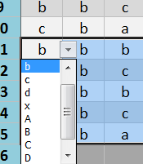

Step 4

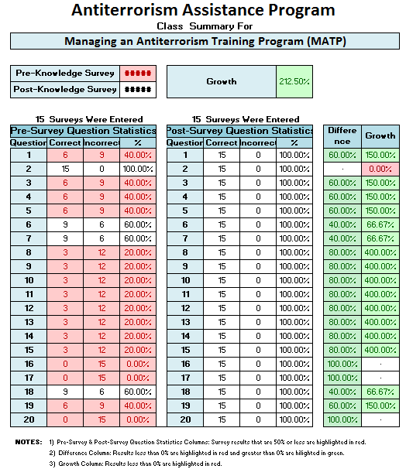 | - Select the Summary tab at the bottom of the workbook screen.  - This is a summary of the responses to each survey question showing the number correct, incorrect, and the percentage correct.

Step 5

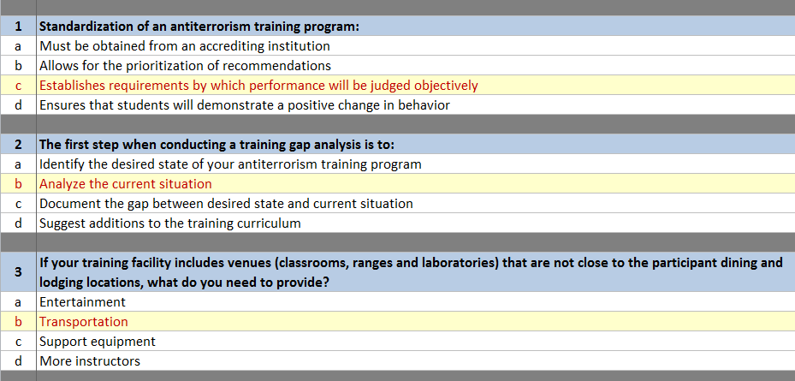 | - Select the Statistics tab located at the bottom of the workbook screen.  - You will see a representation of the answer key, with the distribution of answers selected by the participants shown as a percentage.  - This information may help you identify areas where the participants are weak or strong.

Step 6

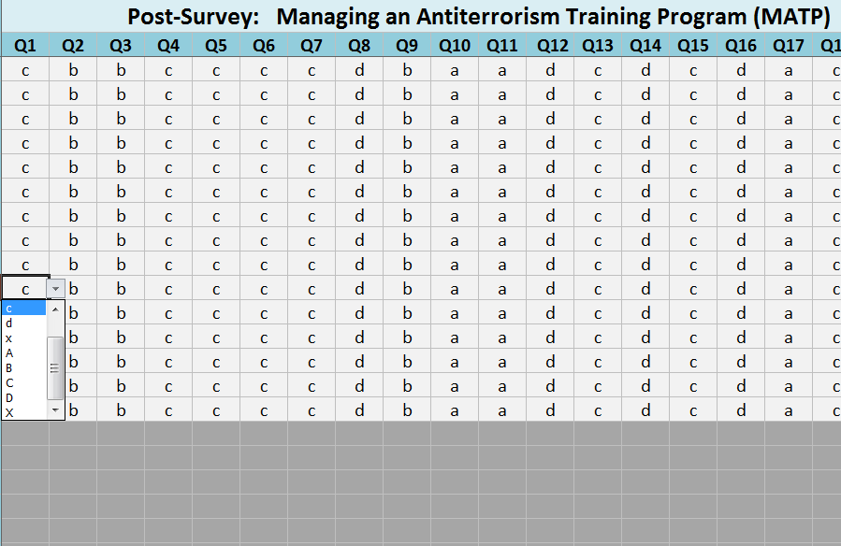 | - Select the Post-Survey Entries tab at the bottom of the workbook screen.  - (Repeat the process in Step 3.)  - Enter the answers as they appear on the individual post-course knowledge survey, starting with Survey No. 1, question 1.  - Entries are not case sensitive.  - If no answer is selected, or if multiple answers are selected, enter "x" for the answer.  - Save the workbook to your hard drive.

Step 7

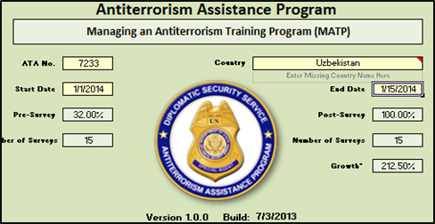 | - Select the Course Info tab at the bottom of the workbook screen.  - Use the data shown in the pre- and post-survey fields to complete your After-Action-Report.  - This information may be shared with participants, if so desired.  - Email the completed Pre-/Post-Course Knowledge Survey Analysis workbook with the AAR to the TDO at completion of training.

Appendix C: Jeopardy Game Answer Key
Critical Infrastructure Security and Resilience Jeopardy Game Questions & Answers
There are twenty knowledge survey questions and twenty-five Jeopardy answers; the extra five answers will not have a knowledge survey question cross-reference number in the right column.

Critical Infrastructure
Game Board | Point Values and Module/Knowledge Survey References
QUESTION: The comprehensive evaluation of the functional components of a given critical infrastructure is called ________________.  ANSWER: Critical infrastructure assessment | 100 Points  (Module 5, Objective 1, Slide 6, Knowledge Survey Question 1)
QUESTION: During a critical infrastructure assessment, a “data call” refers to:  ANSWER: Requesting information about the site prior to the site visit | 200 Points  (Module 5, Objective 2, Slide 33, Knowledge Survey Question 4)
QUESTION: What is the third function of a physical protection system?  ANSWER: Response | 300 Points  (Module 2, Objective 4, Slide 51, Knowledge Survey Question 2)
QUESTION: What should occur in Phase 4 of the vulnerability analysis for a physical protection system?  ANSWER: Conducting a gap analysis | 400 Points  (Module 2, Objective 6, Slide 65, No Corresponding Knowledge Survey Question)
QUESTION: What are the four categories of critical assets?  ANSWER: People, information, equipment, and processes | 500 Points  (Module 2, Objective 3, Slide 20, Knowledge Survey Question 3)

Miscellaneous
Game Board | Point Values and Module/Knowledge Survey References
QUESTION: Any observed behavior that could indicate terrorism or terrorism-related crime is considered ____________________.  ANSWER: Suspicious activity | 100 Points  (Module 4, Objective 1, Slide 4, No Corresponding Knowledge Survey Question)
QUESTION: What is a community partnership?  ANSWER: When law enforcement agencies and the community and organizations they serve working together for the purpose of developing solutions to problems and increasing trust in law enforcement. | 200 Points  (Module 4, Objective 2, Slide 11, Knowledge Survey Question 5)
QUESTION: Identifying all _________________ is necessary before conducting an asset analysis.  ANSWER: Critical assets | 300 Points  (Module 6, Objective 1, Slide 8, Knowledge Survey Question 6)
QUESTION: What is any circumstance or event with the potential to adversely affect an information system by way of unauthorized access, destruction, disclosure, modification of information, or denial of service?  ANSWER: Cyberthreat | 400 Points  (Module 7, Objective 1, Slide 3, Knowledge Survey Question 8)
QUESTION: Since it is not possible or practical to protect all critical infrastructure assets, you must:  ANSWER: Prioritize protection for assets according to their importance | 500 Points — (Daily Double)  (Module 6, Objective 2, Slide 11, Knowledge Survey Question 7)

Surveillance and Security
Game Board | Point Values and Module/Knowledge Survey References
QUESTION: As terrorist organizations prepare to launch an attack against a critical infrastructure site, ___________________ can be the weak link in the preparation process.  ANSWER: Surveillance | 100 Points  (Module 8, Objective 4, Slide 15, Knowledge Survey Question 10)
QUESTION: Distance is the most effective security measure against ___________________________.  ANSWER: A large vehicle-borne improvised explosive device | 200 Points  (Module 9, Objective 2, Slide 38, Knowledge Survey Question 13)
QUESTION: Unusual activities, such as taking quick photos of a site using a cell phone, can be an indicator of:  ANSWER: Hostile surveillance | 300 Points  (Module 8, Objective 4, Slide 18, Knowledge Survey Question 11)
QUESTION: Which type of IED currently poses the most destructive threat to a critical infrastructure?  ANSWER: Vehicle-borne IEDs (VBIEDs) | 400 Points — (Daily Double)  (Module 9, Objective 2, Slide 39, Knowledge Survey Question 14)
QUESTION: What are the three elements of resilience planning?  ANSWER: Robustness, resourcefulness, and rapid recovery | 500 Points  (Module 7, Objective 3, Slide 25, Knowledge Survey Question 9)

Threats
Game Board | Point Values and Module/Knowledge Survey References
QUESTION: What is the overall purpose of a threat analysis statement?  ANSWER: Gather intelligence information on one or more threats | 100 Points  (Module 10, Objective 1, Slide 4, Knowledge Survey Question 14)
QUESTION: In a physical protection system, what is detection?  ANSWER: A process in which an alarm sensor activates due to an intrusion, a nuisance alarm, or false alarm | 200 Points  (Module 12, Objective 1, Slide 4), Knowledge Survey Question 16)
QUESTION: When a bomb threat is received, the decision options are to search, evacuate, or ignore the threat. What should this response decision be based on?  ANSWER: Previously defined policies and procedures | 300 Points  (Module 11, Objective 4, Slide 74, No Corresponding Knowledge Survey Question)
QUESTION: What are the four primary elements that contribute to the effectiveness of a security force?  ANSWER: Appropriate supervision, selection of security force members, initial and continuous training, and deployment of adequate equipment | 400 Points  (Module 12, Objective 2, Slide 44, Knowledge Survey Question 17)
QUESTION: What is the purpose of having written procedures pertaining to critical infrastructure security?  ANSWER: Provide consistent security force response | 500 Points  (Module 11, Objective 1, Slide 8, Knowledge Survey Question 15)

Technology & Operations
Game Board | Point Values and Module/Knowledge Survey References
QUESTION: What is the function of a passive sensor?  ANSWER: It detects some type of energy emitted by the intruder | 100 Points — (Daily Double)  (Module 13, Objective 2, Slide 13, Knowledge Survey Question 18)
QUESTION: What is a written order for implementing and conducting a security inspection and validation program?  ANSWER: Security inspection and validation program directive | 200 Points  (Module 14, Objective 2, Slide 20, No Corresponding Knowledge Survey Question)
QUESTION: What is the name of the phase of the security inspection validation when you identify assets associated with the critical infrastructure?  ANSWER: Phase 1: Inspection planning | 300 Points  (Module 14, Objective 3, Slide 23, Knowledge Survey Question 19)
QUESTION: Which of the following is a management tool used to compare the actual performance of an existing physical protection system with its potential performance?  ANSWER: Gap analysis | 400 Points  (Module 15, Objective 3, Slide 21, No Corresponding Knowledge Survey Question)
QUESTION: What are the steps of the gap analysis process?  ANSWER: Step 1: Determine expected standard requirements, Step 2: Assess existing performance levels, Step 3: Identify gaps, Step 4: Define risk management plan | 500 Points  (Module 15, Objective 3, Slide 25, Knowledge Survey Question 20)

Appendix D: Course Materials and Equipment
The course equipment list details the materials needed for you and participants to be successful in the course. ATA will order and ship most of the equipment to the embassy. However, the lead facilitator is responsible for checking with the RSO to ensure all equipment and materials arrive and for acquiring other materials, as needed, during course preparation.

The following materials are included in the course equipment list to facilitate training. If an item is missing, coordinate with the RSO to borrow, rent, or purchase the required item.

Item | Specifications and Full Description | Each
TO GO KIT | NO ENTRY BY TCD; TO BE PROVIDED BY TDD to include Instructor Laptop Computer and Projector | 1
Cameras | Digital; 16 megapixel CCD sensor; 16x optical zoom; 4x digital zoom; 5–80mm focal length lens (35mm equivalent: 28–448mm); aperture range of f/3.5–f/5.9; internal flash with auto and manual on-off; 720p HD video; 3-inch LCD; JPEG and MOV file formats; operating on AA batteries (Canon SX160 IS or comparable); with minimum 2GB SD memory card | 4
Thumb Drive | 8 GB USB Thumb Drives | 26
Rangefinder | Laser; Magnification 6x; Objective Lens Diameter 21mm; Angle of View 6.0°; Field-of-View (@ 1000 Yds) 315' (105 m @ 1000 m); Focusing Range & Accuracy 10-500 m ±1 m to 250 m; range displayed in meters and/or yards; Relative Brightness 12.3; Twilight Factor 11.2; Waterproof and fogproof; powered by included CR2 3-volt battery (Example: Nikon ProStaff 550 Laser) | 4
SD Card | 8 GB storage, To Fit Camera | 4
Padfolios | ATA vinyl padfolio w/lined paper pad | 26
Markers | Dry Erase; multi-color; pack of 4 | 4
Letter/Package IED Bomb Poster | Envelope IEDs, Letter/Mail Bombs Poster (OTA-994); Inert Products Company; No Substitutions | 1
Vehicle-Borne IED Awareness Poster | Vehicle-Borne Improvised Explosive Devices (VBIEDs) Awareness Poster (OTA-990); Inert Products Company; No Substitutions | 1
CBRN Poster | WMDs, Chemical and Biological Dispersal Devices Awareness Poster (OTA-976) ; Inert Products Company; No Substitutions | 1

Appendix E: Course Schedule
Week | Day 00 | Day 00 | Day 00 | Day 00 | Day 00
00 |  |  |  | Facilitator Preparation
Week | Day 01 | Day 02 | Day 03 | Day 04 | Day 05
01 | M01: Course Introduction  (2 Hours)  M02: Introduction to Critical Infrastructure Security and Resilience  (4 Hours) | M03: Community Engagement and Human Rights  (1.5 Hours)  M04: Building Community Partnerships  (1 Hour)  M05: Critical Infrastructure Components  (4.5 Hours) | M06: Critical Infrastructure Assets  (4 Hours)  M07: Cybersecurity  (2 Hours)  M08: Surveillance Awareness: What You Can Do  (1 Hour) | M09: Explosives and Critical Infrastructure  (3.5 Hours)  M10: Analyzing the Threat  (3 Hours) | M10: Analyzing the Threat (Cont’d.)  (1.5 Hours)  M11: Policies and Procedures  (4.5 Hours)
Week | Day 06 | Day 07 | Day 08 | Day 09 | Day 10
02 | M12: Security Force Operations  (3.5 Hours)  M13: Security Technology  (3.0 Hours) | M14: Security Inspection and Validation  (2 Hours)  M15: Operational Resilience  (3 Hours)  M16: Capstone Exercise (1.5 Hours) | M16: Capstone Exercise (Cont’d.)  (6.5 Hours) | M16: Capstone Exercise (Cont’d.)  (6.5 Hours) | M17: Summary and Evaluation  (6.5 Hours)

