Participant Critique of Training

Step Action Guide
The Participant Critique of Training is a MS Excel spreadsheet intended to benefit ATA during the periodic updating of training material.
- The form is completed electronically and it is completed by the interpreters. Upon completion of the course, interpreters will save the electronic spreadsheet to a thumb drive, or, directly to the hard drive of the laptop provided by the instructor. He/she will leave the thumb drive with the Lead Facilitator after completing the data entry of student comments.
- The completed spreadsheet is emailed to the TDO electronically by the Lead Facilitator, as is the Pre Post Knowledge Survey and After-Action-Report. Note: original copies of the Critiques of Training and the Pre/Post Knowledge Survey must continue to be forwarded to the TDO to comply with Federal regulations.
- The statistical information contained in these electronic spreadsheets is uploaded electronically into the course evaluation database maintained by ATA for comparative analysis.
Below are instructions that will guide you through the process of completing the spreadsheet.
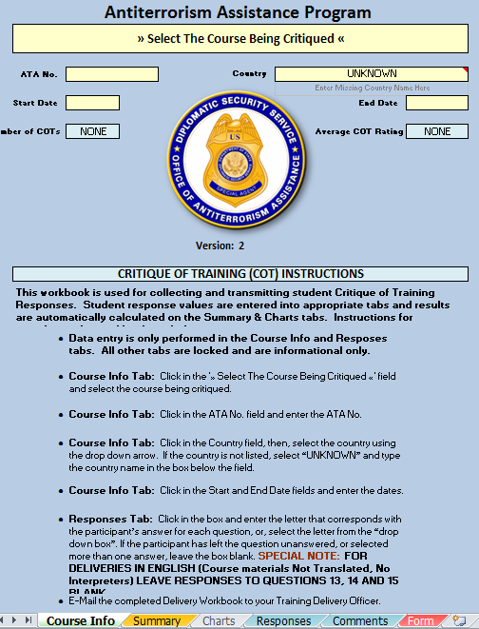 | Open the workbook to the sheet marked “Course Info”  Note that instructions for completing the workbook are also noted on this sheet.

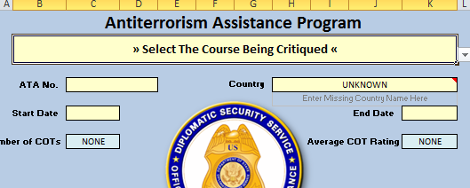  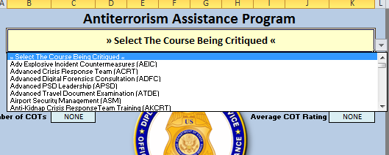 | Click on the down arrow to open the drop-down list of courses.  Then, select the title of the desired course from the list.
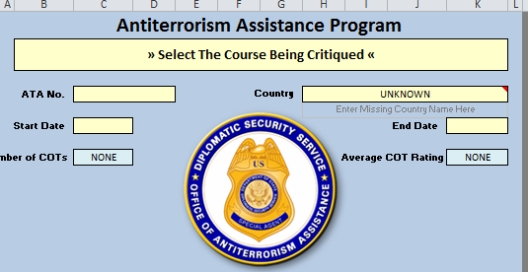 | Enter the ATA number and the course start and end dates in the shaded cells.
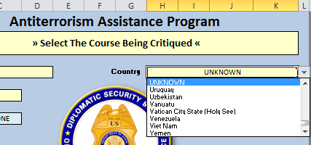  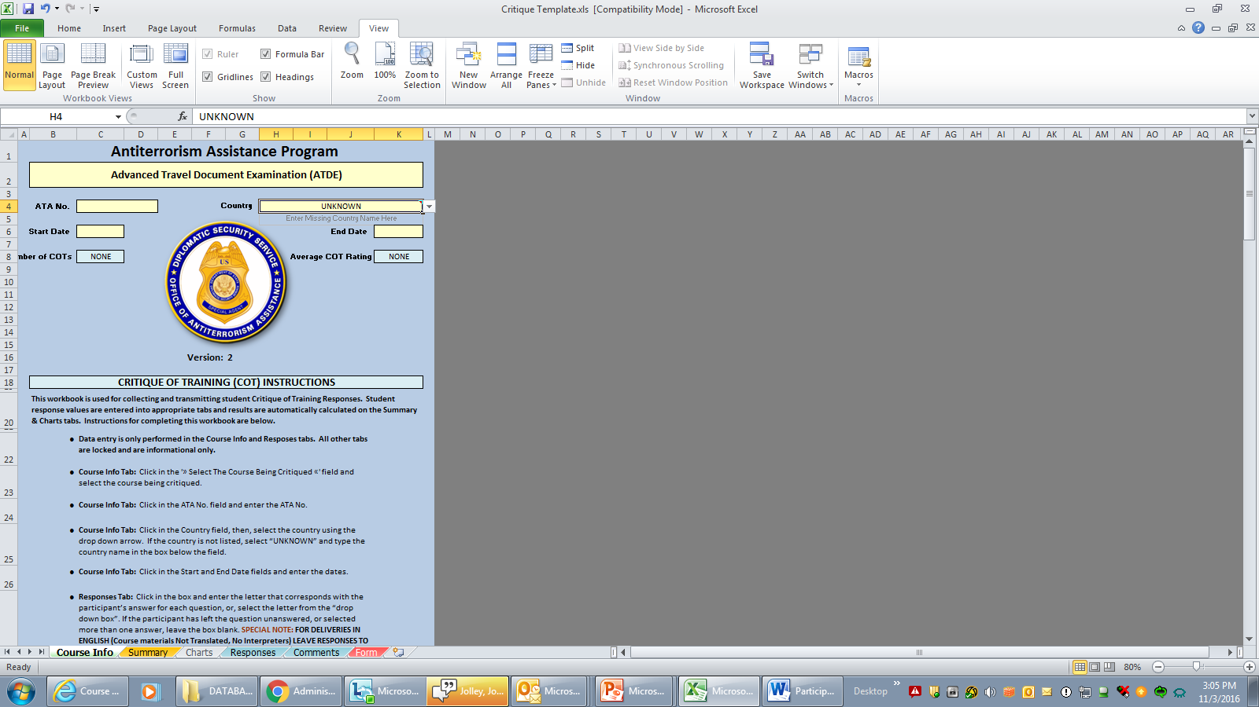 | Click on the down arrow to open the drop-down list of Countries. Then, select the title of the desired country from the list.  If the country is not in the list, type the name of the country in the box adjacent the Country field.

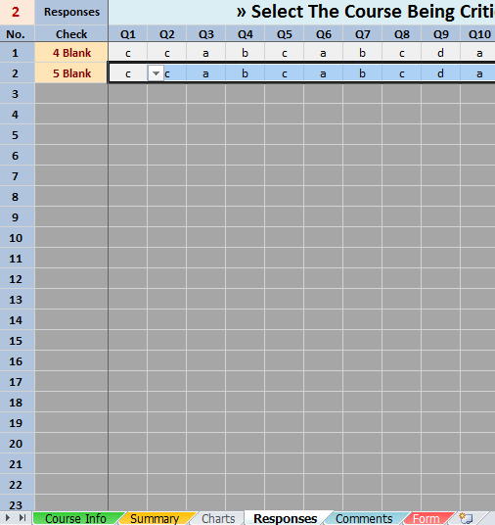 | Select the “Responses” tab located at the bottom of the workbook screen.  Enter the answers as they appear on the individual Critiques starting with Test No. 1, question 1.  Note: you may type the letter (fastest) or use the drop down box and select an answer. Entries are not case sensitive. If you type an invalid entry the program will alert you.  If no answer is selected, or if multiple answers are selected, leave the cell blank.

. 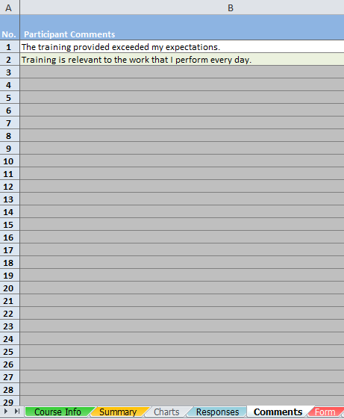 | Select the “Comments” tab located at the bottom of the workbook screen.  Enter the comments as they appear on the individual Critiques.  Save the workbook to your hard drive using the following format: Course Acronym-ATA [space] number [space] Critiques [space] Country name.  Example: CRT-123XYZ Critiques USA  Hand thumb drive to the Lead Facilitator after all entries have been made.

