Pre/Post Test Question Analysis Workbook

Step Action Guide
The Pre/Post Test Analysis Workbook is a MS Excel product intended to benefit both course facilitators and the Training Curriculum Division of ATA.
- There is no longer a need for facilitators to “grade” tests as entering the answers selected by participants automatically scores all tests and completes the calculations as they are entered by the facilitator.
- Facilitators can refer to the “Summary” and “Statistics” Tabs after entering the Pre-Test answers as a means of identifying areas where participants may be weak or have knowledge. This can help the instructor team plan how to use available training hours most efficiently so as to maximize learning.
- The completed workbook is emailed to the TDO electronically by the Lead Facilitator, as is the After-Action-Report. Note: original copies of the pre/post tests must continue to be forwarded to the TDO to comply with Federal regulations.
- Statistical information contained in the workbook is uploaded electronically into the course evaluation database maintained by ATA for comparative analysis.
The following step-action guide supplements the workbook instructions and will guide you through the process of completing the Pre/Post Test Question Analysis workbook.
Step One:
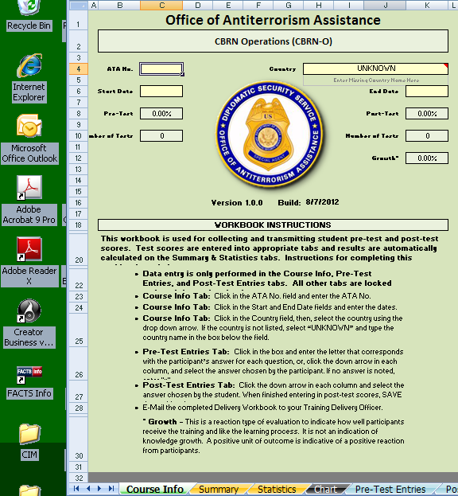 | The Pre/Post Test Question Analysis workbook is found in the LEAD folder of the Facilitator CD.  Copy and save the program to your computer hard drive.  When the workbook is opened you should see the Course Info Tab worksheet displayed.  Instructions for completing the workbook are shown at the bottom of this page.

Step Two:
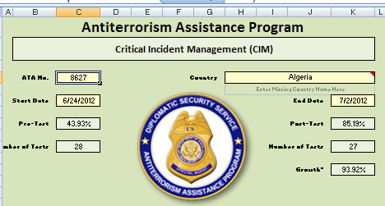 | Enter the ATA number and the course start and end dates in the off-colored cells.
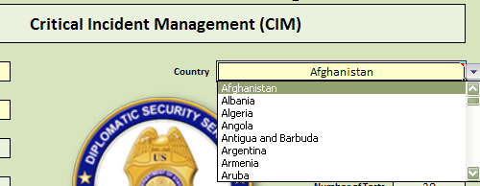  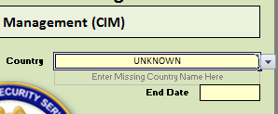 | The Country cell has a drop-down list of current countries where ATA provides training.  Select the country from this list for spelling consistency.  If the country is not on the list type the name of the country in the box directly below the Country field.  Save the workbook to your hard drive.

Step Three:
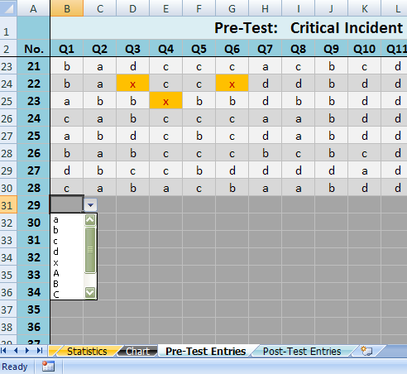 | Select the Pre-Test Entries tab at the bottom of the workbook screen.  Enter the answers as they appear on the individual Pre-Knowledge Survey tests starting with Test No. 1, question 1.  Note: you may type the letter (fastest) or use the drop down box.  Entries are not case sensitive. If you type an invalid entry the program will alert you.  If no answer is selected, or if multiple answers are selected, enter the letter “x” in the cell.  Save the workbook to your hard drive.

Step Four:
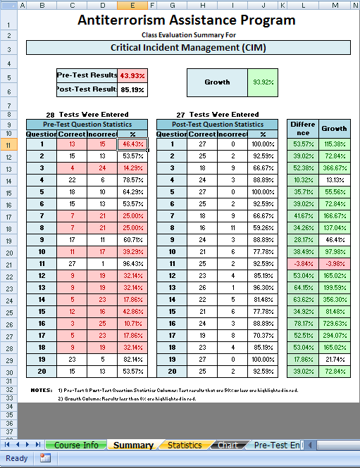. | Select the Summary tab at the bottom of the workbook screen.  This is a summary of the responses to each test question showing the number correct, incorrect, and the percentage correct.

Step Five:
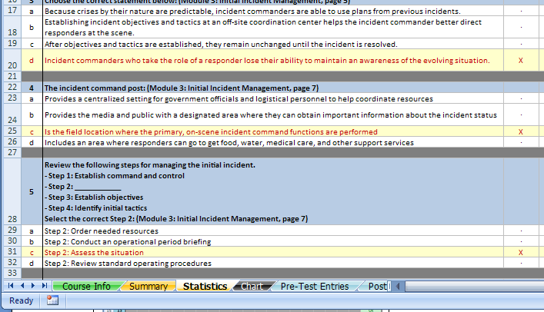 | Select the Statistics tab located at the bottom of the workbook screen.  You will see a representation of the answer key with the distribution of answers selected by the participants shown as a percentage.  This information may help you identify areas where the participants are weak or strong.

Step Six:
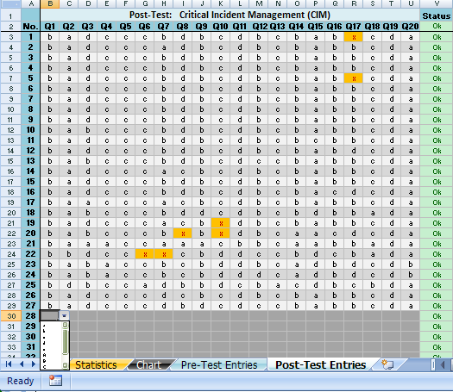 | Select the Post-Test Entries tab at the bottom of the workbook screen.  (Repeat the process in Step Three)  Enter the answers as they appear on the individual Post-Knowledge Survey tests starting with Test No. 1, question 1.  Entries are not case sensitive.  If no answer is selected, or if multiple answers are selected, enter “x” for the answer.  Save the workbook to your hard drive.

Step Seven:
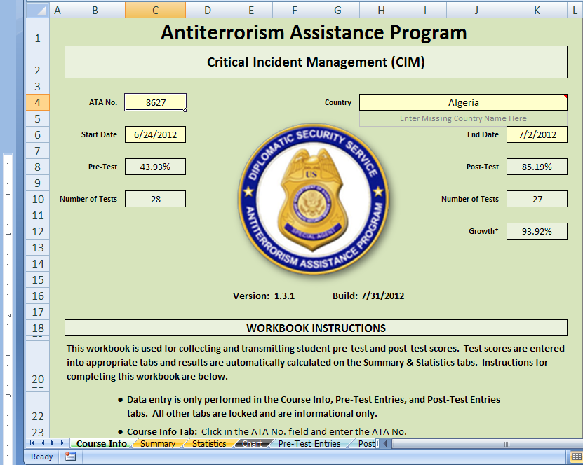 | Select the Course Info tab at the bottom of the workbook screen.  Use the data shown in the pre- and post-test fields to complete your After-Action-Report.  This information may be shared with participants, if so desired.  Email the completed Pre/Post Test Question Analyst workbook with the AAR to the Training Delivery Officer (TDO) at completion of training.

