Participant Training Delivery Report (TDR)

Step Action Guide
The TDR is intended to benefit ATA during the periodic updating of training material. It is intended to be a journal style document that builds on itself throughout an ATA training activity. This format replaces the Instructor After-Action Report (AAR), notifying ATA using either a formal report, as some TDCs require, or emails.
- The TDR is a weekly journal of training observations made by the Lead Instructor in the delivery of ATA training.
- The completed TDR is emailed to the TDO electronically by the Lead Facilitator, as is the Pre Post Knowledge Survey, the Participant Critiques, the Skills Evaluation, the 360 degree peer review, and the Data Capture Sheet. Note: original copies of the Critiques of Training and the Pre/Post Knowledge Survey must continue to be forwarded to the TDO and the contract vendor.
Below are instructions that will guide you through the process of completing the TDR. Contact the TDO immediately if: there are any questions or concerns regarding the completion of these forms, if forms are missing, or the wrong forms were provided.
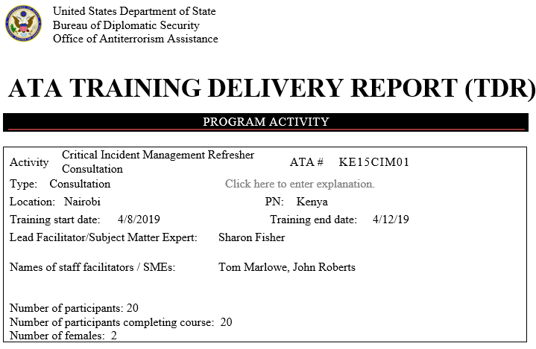 |  | All sections of this page must be completed. For the Activity, note the training/course name (Surveillance Detection) The ATA # is provided by the TDO or your Contractor. Use the pull down arrow to select the Dates, and “Type” of training. Ensure that all fields are completed and that the information is accurate. Incomplete or inaccurate information of any course report will result in the form being returned to the instructor and Contract Vendor.
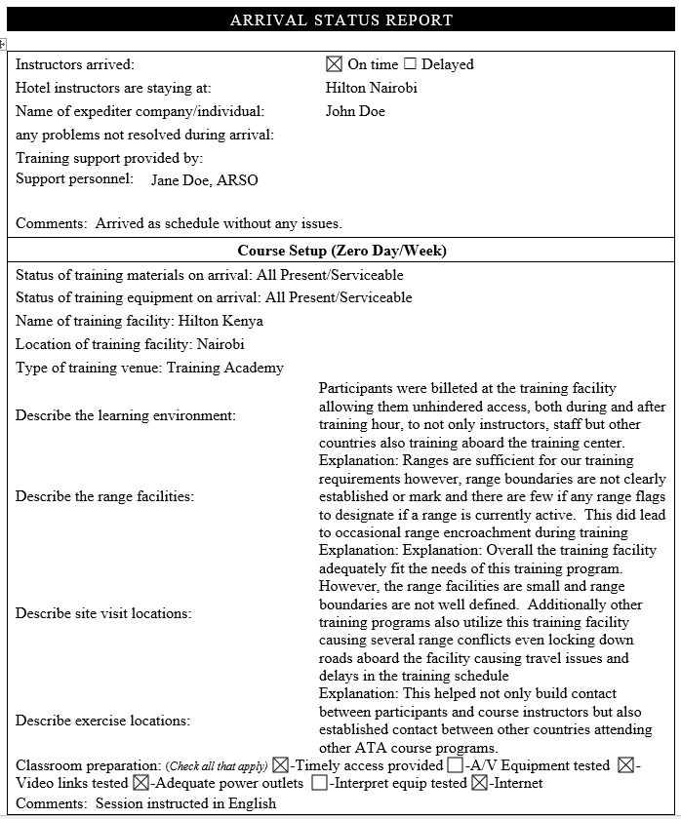 |  | Complete all cells of this section.  These have a drop down arrow to select the answer from. Choose the best answer from the list.  After you have completed the Arrival Status Report, you must email the saved TDR to the TDC and Contract Vendor within 48 hours of arrival.
 | 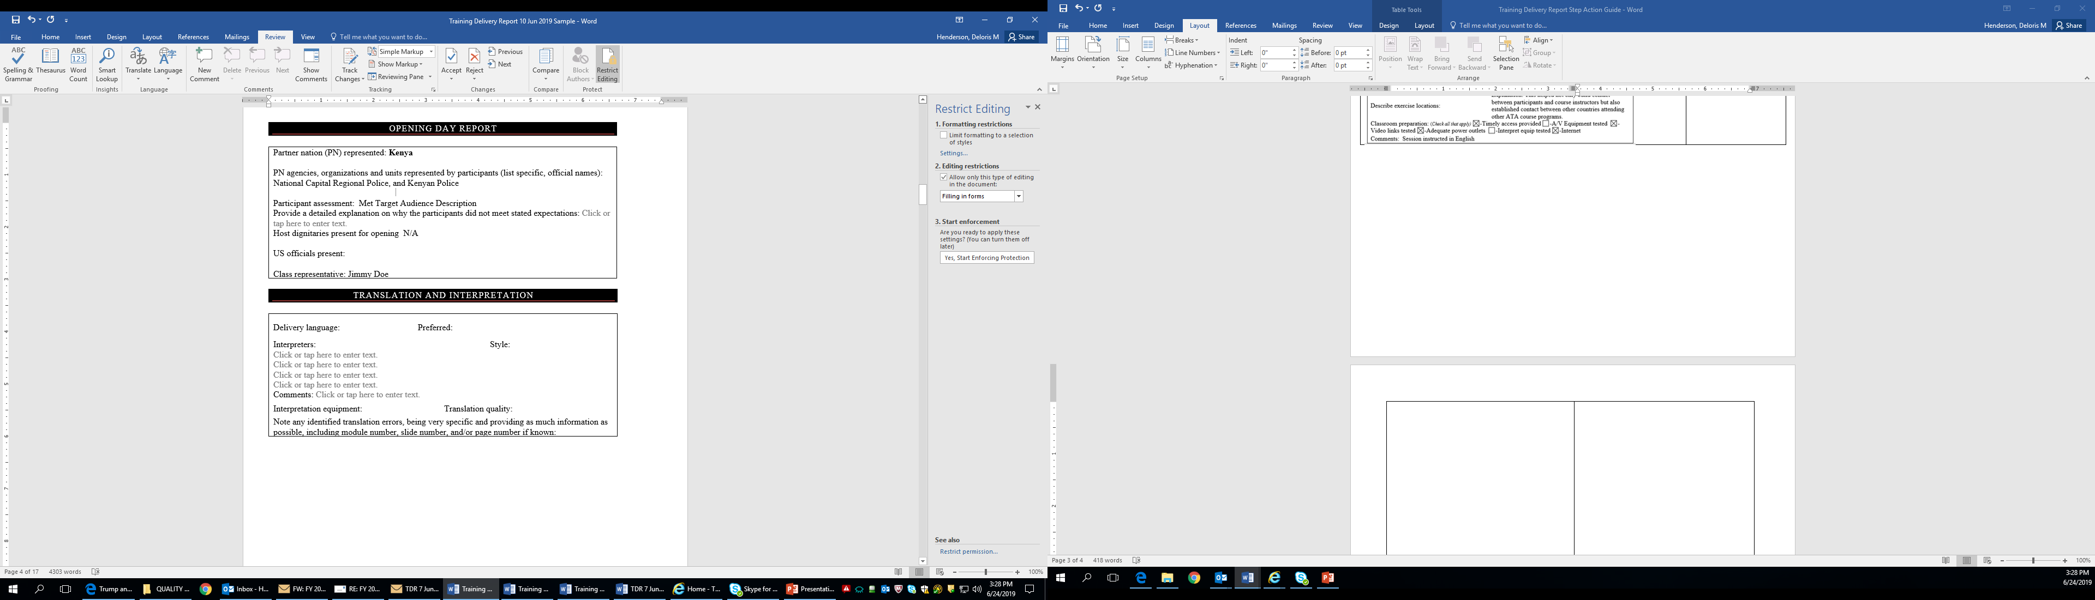 |  | Complete all cells of this section of the Opening Day Report. Enter None or N/A if appropriate.  You must email the entire saved TDR to the TDC and the Contract Vendor within 48 hours of the opening day.

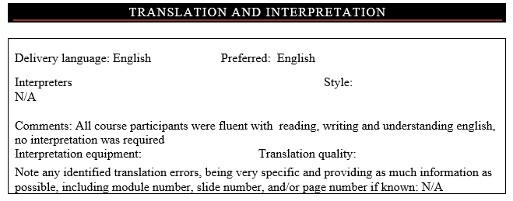 | These have a drop down to select the answer from. Choose the best answer from the list.

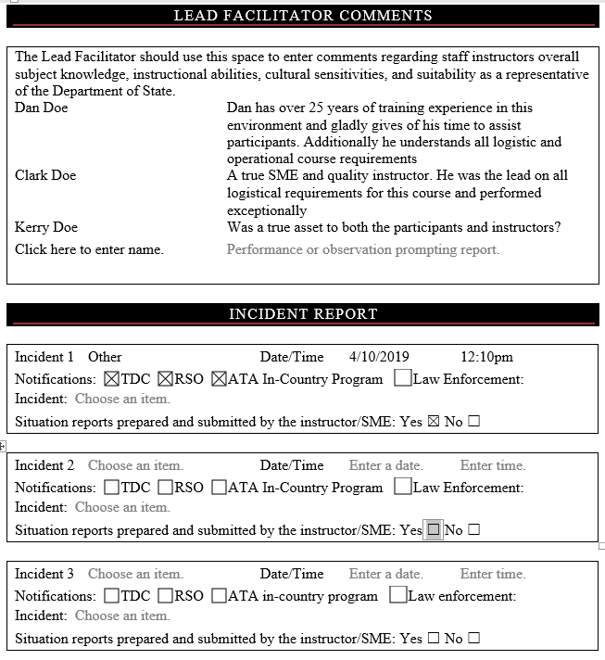 | Complete all cells of these sections.  These have a drop down arrow to select the answer from. Choose the best answer from the list.  Use the drop down to select date.

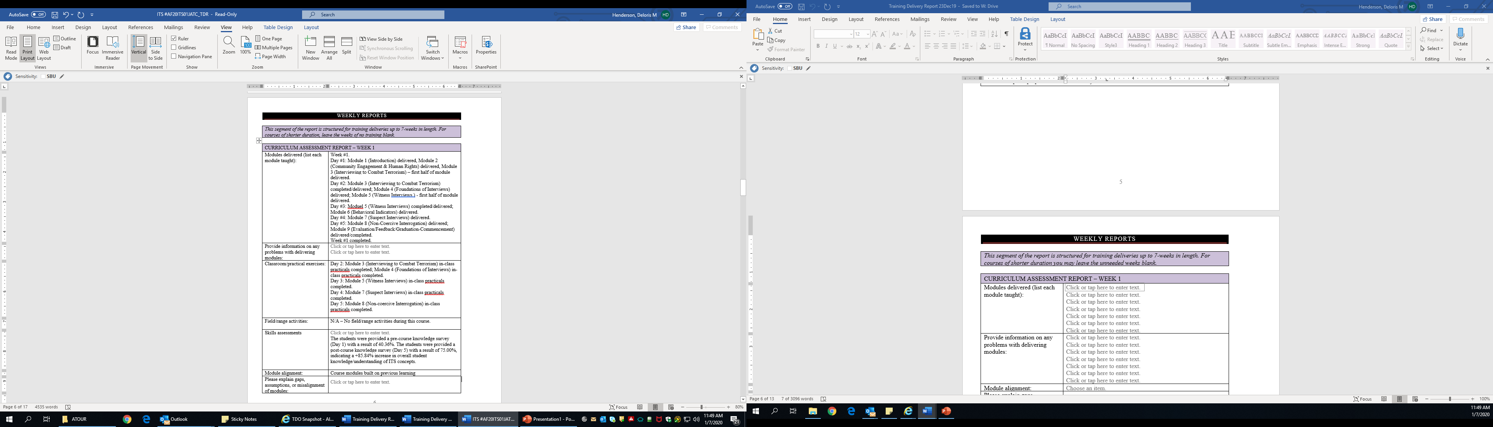 | Complete all cells of this section for all weeks of training. You will continue to email the saved TDR at the end of each week until the course has ended.  Note modules covered for each day of the week.  Use the drop down to select date.

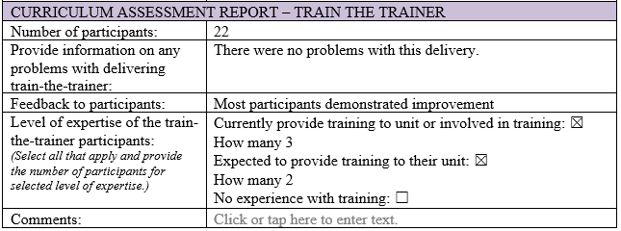 | Complete all cells of this section if course is offered as or with “Train the Trainer”.

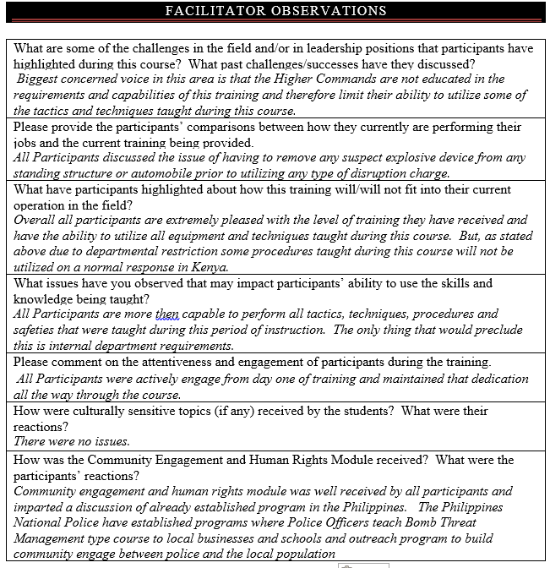 | Complete all cells of this section.

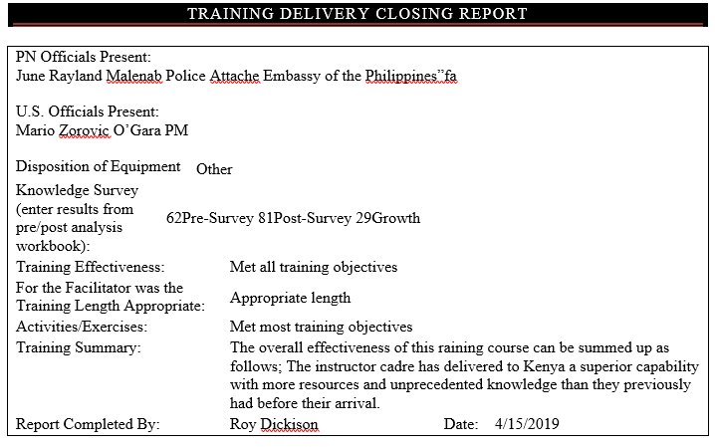 | Answer all sections  These have drop down arrows to select the answer from. Choose the best answer from the list.

Follow Completion and Mailing Instructions found in the Training Delivery Report.

