
Workbook 9.1: IED ACTIVATION Methods
Purpose: | To present information about IED activation methods

Activation Methods
Improvised explosion devices (IED), use one of three major types of activation methods:
- Time-activated
- Victim-activated
- Command-activated

Time-Activated Methods
- Function: initiation occurs after a set time is reached.
- Advantage: provides sufficient time for the terrorist to escape.
- Disadvantage: to maximize effectiveness, the target must maintain a set pattern or routine.
Photo source: ATF
Table 1: Common Time-Activated Switches
Type | Photo | Description
Mechanical timers | 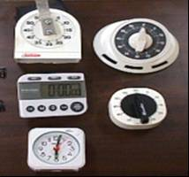 | Terrorists can set a clock, watch, or appliance timer to operate on a time delay that will trigger the device or arm the device.  The timer is a component in the IED and acts as a switch in the circuitry.  Terrorists set the delay. When the hand and wire make contact, it completes the circuit between the power source and the main charge.
Digital and electronic timers | 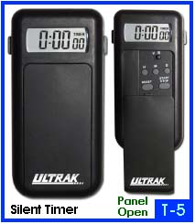 | Digital and electronic timers are more common today. You can set them to activate months ahead on a certain date, hour, and minute.  The device pictured here, for example, can be set to activate 12 days in advance of the planned attack. The time-keeping mechanism of these devices is very accurate.
Chemical reaction delay |   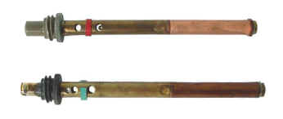  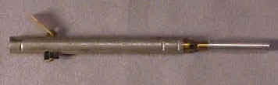 | Terrorists mix chemical agents, including some household chemicals together, usually in a closed or sealed container.  Over time, the mixture becomes heated; the heat reaction causes the container to expand and the container explodes.  Another type of chemical reaction occurs when the terrorist places a chemical in a capsule or container that will react with the chemical and over time dissolves or breaks.  To the left is another example of using a chemical reaction time delay. These military time pencil detonators were manufactured to delay from 10 minutes up to 24 hours. A time pencil detonator was used in the July 20, 1944, briefcase bomb attack against Adolph Hitler.
Time-delay burning fuse |  | A burning fuse is a tube or cord filled or saturated with combustible material that terrorists use to detonate explosions. The fuse burns at a specific rate and when the flame and heat makes contact with the explosive material, a detonation occurs. The fuse, however, is unpredictable and may not ignite. In the case of Richard Reid, the shoe bomber, his attempt to blow up the aircraft failed because the fuse failed to ignite.

Victim-Activated Methods
- Function: initiation occurs as a result of the victim’s actions.
- Advantage: terrorist need not be present because the device is activated by the victim.
- Disadvantage: the victim of the device may not always be the intended target.

Table 2: Common Victim-Activated Switches
Type | Photo | Description
Disturbance switches  Mercury | 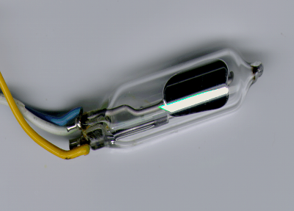 | A mercury switch works on the principles of gravity or heat. It is common for terrorists to use this device as a disturbance switch.  When the mercury makes contact with the conductors, the circuit is completed and the device functions.  Movement of the device, such as by turning, lifting, or kicking will cause the device to function.
Pressure or pressure-release micro switch | 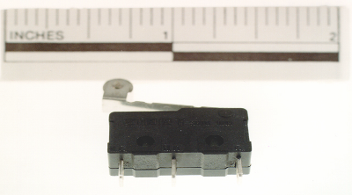 | This photo shows a commercially manufactured micro pressure switch. The switch has three connections, which allow it to be wired as normally open “NO” or normally closed “NC.”  For example, it may be wired “NC” in a closed brief case and when the briefcase is opened, the device detonates.  This type of switch may also be wired into a circuit as an antidisturbance switch to prevent opening prior to the intended activation of the firing switch.
Pull switch  Clothespin | 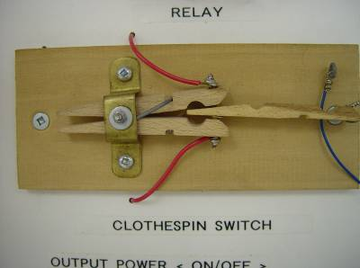 | This photo represents a clothespin type pull switch, which is a very simple switch.  In a pull switch, the pins are secured in the open position with a piece of wood or any nonconductive material in between the conductors. Wires are attached to thumbtacks at each end of the jaws of the pin.  When the wood is pulled from the jaws, the thumbtacks make contact with each other completing the circuit and detonating the device.
Pull switch  Loop switches | 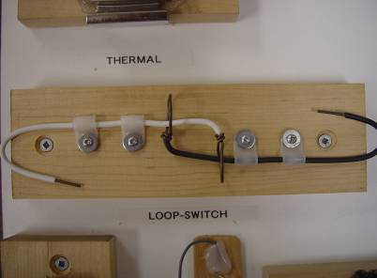 | This photo is an example of a loop type pull switch.  Loop switches have two separate wires with a loop at each end of the wire. Each wire is run through the other wired loop.  When the two wires are pulled together, the loops make contact with each other, complete the circuit and the device detonates.
Barometric pressure | 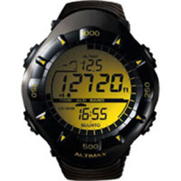 | This watch has a barometric pressure alarm, which can be wired to an IED. IEDs can be triggered using a barometric sensor that detonates once it reaches a specific atmospheric pressure.  A similar type of device was used in December 21, 1988, for the bombing of Pan Am Flight 103 over Lockerbie, Scotland. The intent was for the device to detonate over the Atlantic Ocean, but due to a delay, the time delay arming switch activated early and the device detonated over land, killing 270.
Temperature | 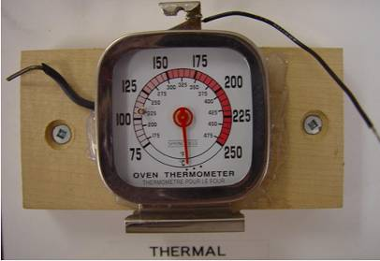 | This photo shows a temperature type switch. Temperature IEDs trigger once a target reaches a certain temperature.  An example is using a thermometer on a vehicle’s engine. As the engine gets hotter, the mercury rises and makes contact with the wires to complete the circuit and create detonation. A simple oven thermometer can also be used as a switch.
Light sensitive | 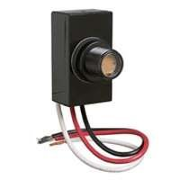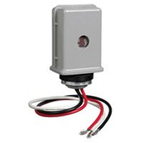 | These devices are examples of light sensitive type switches sold in electronic stores. A light sensitive IED triggers when light or darkness activates a sensor.  An example is an automatic light switch that activates upon darkness, or a switch that activates when it detects light.
Infrared  Passive infrared  Active infrared | 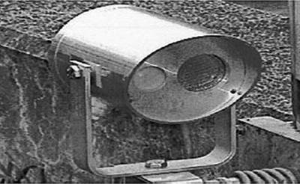 | This photo illustrates an example of an infrared type switch.  Passive infrared sensors are electronic devices commonly used in commercially made motion detectors, which are used for triggering intruder alarms and other security systems.  Motion is detected by an object of a certain temperature (such as a human) passing in front of something of another temperature (such as a wall).  An active infrared sensor emits a beam to a receiver forming an invisible link that, when broken, acts as a trigger to initiate the IED. An active infrared sensor is like an electronic version of a trip wire. Infrared sensors are used frequently in roadside bombs.
Sound or voice | 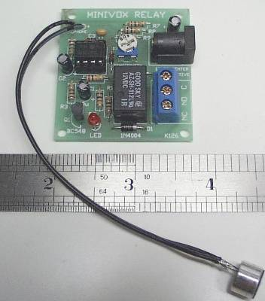 | This photo shows a small sound-activated sensor used as a switch.  A sound-activated sensor is similar to the device found in a voice-activated recorder or noise-activated switches, such as those that turn on lights.  These sensors can operate on the same principal in an IED — when activated by sound, the device detonates.  However, in order to work, this type of firing switch requires a time delay arming switch in the circuit.

Command-Activated Methods
- Function: initiation occurs through the use of remote control device or command wire.
- Advantage: allows terrorist to choose the optimum moment of initiation.
- Disadvantage: the terrorist must be within the frequency range of the receiver and transmitter and generally be able to see the target in order to know when to detonate the explosive.

Table 3: Common Command-Activated Switches
Type | Photo | Description
Remote control | 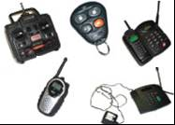 | Remote controls having a receiver and transmitter may be used to complete a circuit.  Remote control items, such as garage door openers, toy vehicles, and car alarms can be used to transmit a signal to the receiver switch wired into the device. This will complete a circuit that detonates the device.  These devices have a significant variance in their range capabilities. A cell phone is basically unlimited, while a wireless doorbell must be very close.
Command wires | 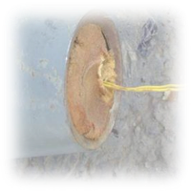 | Command wires control some IED devices. These wires are connected from the initiator to the blasting cap.  Upon initiation, an electrical pulse runs through the wires and detonates the device.

