
Workbook 2.2: Physical Protection System Functions & Activity
Purpose: | To provide information about the functions of the physical protection system

Part 1: Functions of a Physical Protection System
A functioning physical protection system allows for successful detection and assessment of a terrorist action, which results in communicating with and deploying a security force. Once the terrorist is detected, he or she is delayed to allow the security force time to arrive. The security force then interrupts and neutralizes the terrorist.

Figure 1: Physical Protection System — Relationship Functions
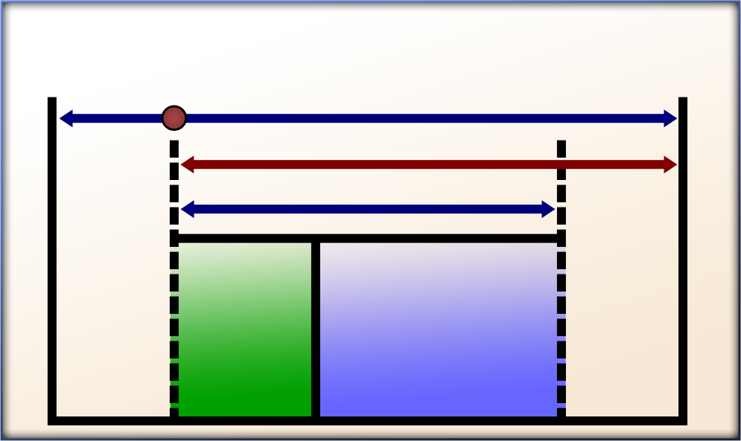
Terrorist begins action
First alarm
Terrorist neutralized
Respond
Terrorist interrupted
Alarm Assessed
Detect and assess
Terrorist task time
Terrorist task complete
Delay
Physical protection system time Required

The relationship of detection assessment, delay, and response is covered in detail in Module 12: Security Force Operations.
Detection and Assessment
Detection is the discovery of a terrorist action and includes the sensing of covert and overt actions. In an effort to discover terrorist actions, three primary events need to occur. First, a sensor must be able to detect the terrorist or unusual occurrence that may take place. Once the sensor is activated, the information should be communicated to notify someone of the occurrence. Lastly, the notification of the alarm needs to be assessed and evaluated to be valid or invalid.

Examples of detection methods include the following sensor technologies:
- Interior
- Infrared
- Microwave
- Proximity
- Boundary penetration
- Sonic
- Vibration
- Electromechanical
- Exterior (environmental factors must be considered)
- Passive or active
- Covert or visible
- Alarm/Communications, such as video
- Entry control
- Badges
- Biometrics

The kinds of sensors, characteristics of each, preferred features, and evaluation criteria are covered in Module 13: Security Technology.
Delay
A terrorist may not always know that detection has occurred and, therefore, may proceed with attack operations. In order to increase the time needed for response by security force, it is important to delay — or slow down — the terrorist’s progress toward the target. The objective of the delay function is to ensure that an adequate response force arrives in time to prevent terrorists from accomplishing their goal. Delay can be accomplished by a variety of methods including personnel, barriers, locks, and activated delays. The measure of delay effectiveness is the time required by the terrorist after detection to bypass each delay element.

Elements that delay a terrorist prior to detection are considered deterrents. These elements are typically not evaluated as part of the effectiveness of a physical protection system because they do not provide additional time to respond to the terrorist.
Response
The response consists of the actions taken by the security force to prevent terrorist success. The operational function of the security force includes providing a force sufficient to interrupt and neutralize terrorists before they achieve their goal(s). The security force response is dependent on having prearranged tactical plans, communication devices, and realistic training.

Response effectiveness is measured by the total time it takes for information to be initially communicated to the security force about terrorist action through interruption (or neutralization) of the terrorist action by security force.

Part 2: Physical Protection System Functions Activity
Purpose: | To indicate which function of the physical protection system a specified action describes
Duration: | 10 minutes (5-activity; 5-debrief)
Group composition: | Table groups
Debrief: | Large-group discussion

Directions:
- In your table groups, read the Functions of a Physical Protection System section below and the explanations of each function.
- Discuss the relationship illustrated in Figure 1: Physical Protection System —Relationship with your group.
- Work with your group to complete Table 1: Physical Protection System Function Activity.
- In the second column of Table 1, indicate which function of the physical protection system the action in the first column describes. Then write a brief explanation of your choice of function in the third column.
- Be prepared to share your answers with the class.
Table 1: Physical Protection System Functions Activity
Action | Function of Physical Protection System | Explanation
A motion detection alarm outside the building but on the facility grounds is activated. | detection | The motion sensor allows you to detect the terrorist.
Locks on interior doors interfere with the progress of the terrorist. | delay | The standard locks slow the terrorist down.
Security guards interfere with the terrorist’s progress, questioning the validity of his badge. | delay | The delaying actions of the security guards are allowing the security force time to respond.
Security force personnel deploy to a predefined area to interrupt the progress of the terrorist. | response | The personnel are part of the response to prevent the terrorist from completing his task.
The terrorist is stopped by barbed wire fence outside the facility. | none (deterrent) | The fence functioned as a deterrent and no part of the PPS was activated.
Security personnel point a closed-circuit video camera at the area where a sensor has been activated. | detection or assessment | The security personnel are assessing if the sensor detected a potential terrorist or if the sensor was activated by something else (such as an animal).

Develop Operational Resilience
Module 15

