
Handout 9.2: IED Components Activity
Purpose: | To identify the components of an IED
Duration: | 10 minutes (5-exercise; 5-debrief)
Group composition: | Table groups
Debrief: | Large-group discussion

Directions:
- Work with your group to identify the numbered components that appear in Figure 1: Improvised Explosive Device Components.
- Using the list of components above Figure 1, write the name of the component next to its corresponding number in the table beneath Figure 1.
- Be prepared to share your answers with the class.

- Arming switch
- Container
- Initiator
- Main charge
- Power source for the detonator
- Remote control receiver

Figure1: Improvised Explosive Device Components
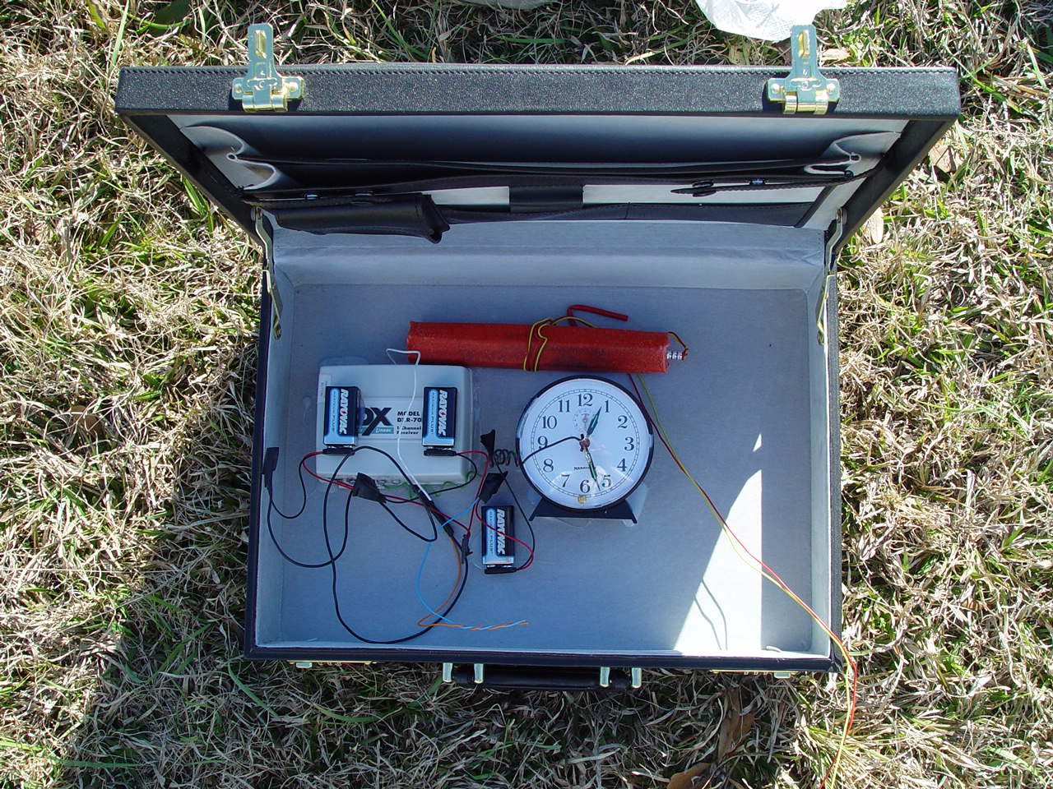
Source: ATF
1.
6.
5.
4.
2.
3.

1. Remote control receiver | 4. Initiator
2. Main charge | 5. Arming switch
3. Container | 6. Power source for the detonator

