
Workbook 2.1: Physical Protection System Course map Diagram
  Purpose:
  To provide a visual illustration of how the course correlates directly to the steps of the vulnerability analysis process
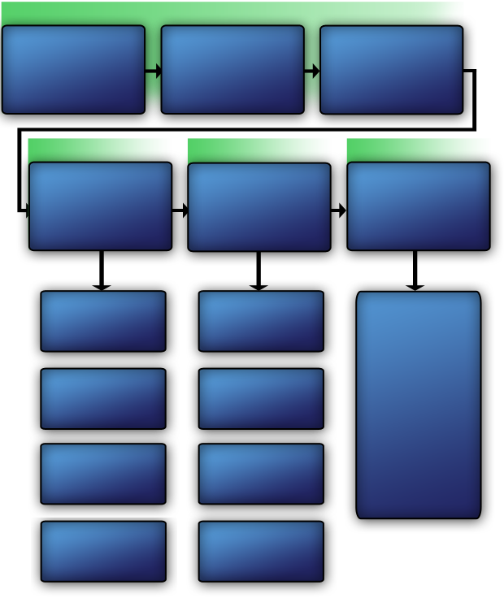
VAM Phase 1

Assess Critical Infrastructure Components
Module 5
Identify Critical Infrastructure Assets
Module 6
Security Inspection and Validation
Module 14
Policies and Procedures
Module 11
Security Technology Module 13
Security Force Operations
Module 12
Identify Critical Infrastructure
Module 2
Analyze the Threat
Modules 7–10

Identify Security Countermeasures
Modules 11–14
VAM Phase 4

VAM Phase 3

VAM Phase 2

Recommendations based on:

- Gap analysis
- Limited scope
performance testing
- Feasibility
- Operational resilience
- Acceptability
Surveillance Awareness: What You Can Do
Module 8
Explosives and Critical Infrastructure Module 9
Analyzing the Threat
Module 10

Cybersecurity
Module 7
Develop Operational Resilience
Module 15

This Page Intentionally Left Blank.
Develop Operational Resilience
Module 15

