
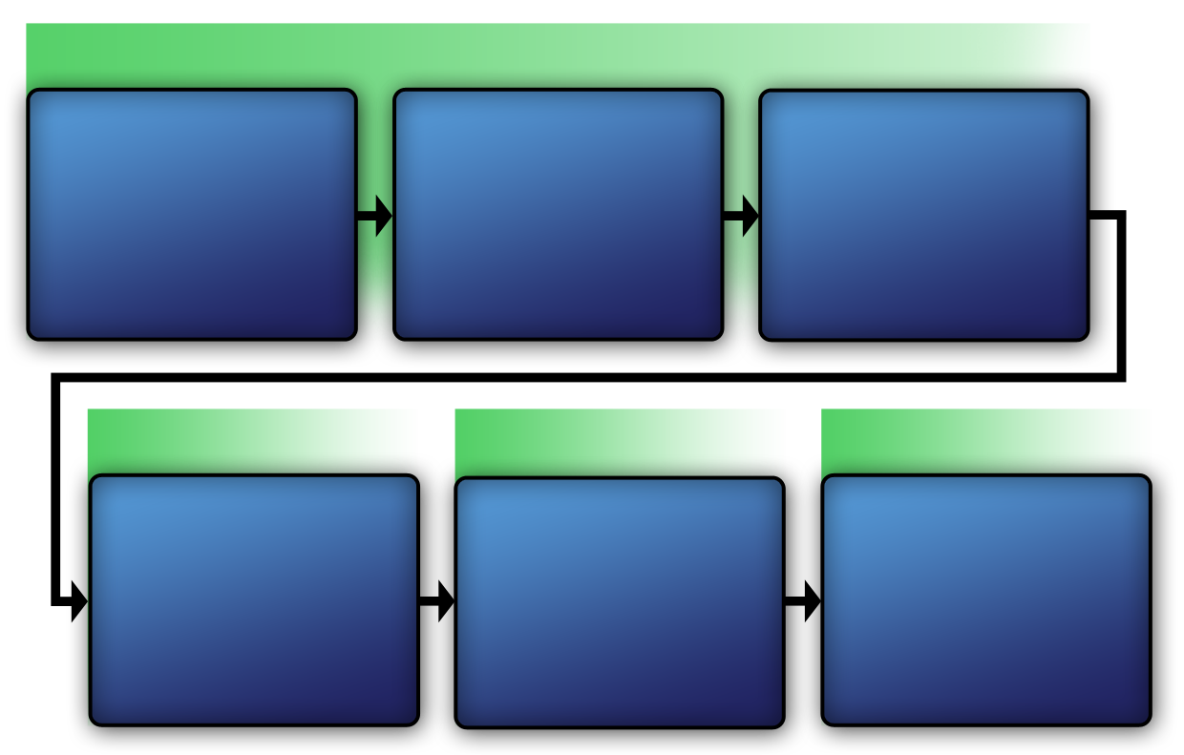
Workbook 2.3: Vulnerability Analysis Methodology Diagram
VAM Phase 2
VAM Phase 1
Analyze the Threat
Identify Critical Infrastructure Assets
Assess Critical Infrastructure Components
Identify Critical Infrastructure

Develop Operational Resilience
VAM Phase 4

VAM Phase 3

Identify Security Countermeasures

This Page Intentionally Left Blank.

