
Workbook 6.2: Threat Spectrum Matrix
Purpose: | To provide a threat spectrum matrix template for future use and an example of a completed threat spectrum matrix

Introduction
The threat spectrum matrix is a template you can copy and use in the future to help identify and select the critical assets needing protection.

In Figure 1: Threat Spectrum Matrix Format:
- The consequence level scale is along the vertical axis of the matrix.
- The probability of occurrence scale is along the horizontal axis of the matrix.
- The qualitative consequence and probability level scales can be high, medium, or low — or whatever scale you decide is appropriate.

Figure 1: Threat Spectrum Matrix Format
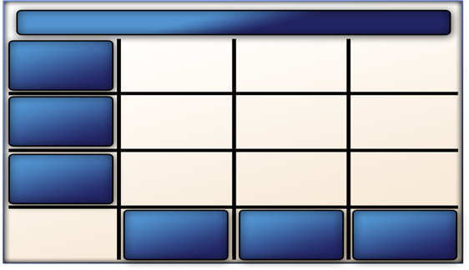
Vertical
Horizontal
Medium
probability
High
probability
Low
probability
Low
consequence
Medium consequence
High
consequence
Facility: Water Treatment Plant

Once you decide on the type of the qualitative scale to use:
- The scale for both the consequences of loss and the probability of occurrence must remain fixed.
- You must use the same type of scale consistently when comparing consequences of loss for all critical assets in a given facility.

Completing the Threat Spectrum Matrix
To complete the threat spectrum matrix, refer to the information gathered from your undesirable consequences of critical asset loss analysis (see Table 4: Asset Protection Decision Matrix — Probability of Occurrence in Addendum 6.2: Undesirable Consequences of Critical Asset Loss Analysis).

Recall from Table 4: Asset Protection Decision Matrix — Probability of Occurrence that loss of life (due to a terrorist bombing of the plant) received a high level of consequence of loss and a high probability of occurrence.
- If you enter both sets of data into the threat spectrum matrix, loss of life will appear in the cell where high consequence and high probability intersect.
- See Figure 2: Completed Threat Spectrum Matrix.

To complete the remaining portions of the matrix, repeat this same step for all information acquired during the undesirable consequences of critical asset loss analysis. In your experience, you will likely find that after completing a threat analysis, the ratings for most of the probability of occurrences will change. For demonstration purposes only, assume the same hypothetical probability levels shown in Table 4 of Addendum 6.2:
- Loss of life (terrorist bomb explosion): high
- Damage to national security (theft of diagram): low
- Interruption of critical facilities (bomb in control room): high
- Environmental damage (hazardous material): medium

Using our hypothetical probability levels:
- The probability that a terrorist would release a hazardous chemical into water treatment machinery is determined as medium because this type of incident has not occurred at any facility in your country, although it has occurred in the region.
- However, the consequences of loss are considered high, since occurrence of such an event could result in significant environmental damage (as well as loss of life or serious adverse impact on the health and safety of employees and community members).

See Table 3: Asset Protection Decision Matrix — Determine Levels of Undesirable Consequences in Addendum 6.2: Undesirable Consequences of Critical Asset Loss Analysis.
- To record this undesirable consequence in the threat spectrum matrix, you would enter environmental damage in the cell where high consequence and medium probability intersect.
- Usually, any asset with high consequence and high probability levels is an asset that requires the highest priority for protection.
- Likewise, any asset assigned low consequence and low probability levels is an asset that only needs the lowest priority for protection when designing a physical protection system.
- Refer to Figure 2: Completed Threat Spectrum Matrix to see where interruption of critical utility services and damage to national security would appear in the matrix.

Figure 2: Completed Threat Spectrum Matrix
Facility: Water Treatment Plant
Damage to national security
Interruption of critical utility services
Environmental damage
Loss of life
Low
consequence
Medium consequence
Low
probability
High
probability
Medium
probability
High
consequence

This Page Intentionally Left Blank.

