
Workbook 12.1: PPS Functional Relationships

Part 1: Intruder Action Timeline Activity
Purpose: | To organize intruder actions in the correct order
Duration: | 10 minutes (5-activity; 5-debrief)
Group composition: | Individuals
Debrief: | Large-group discussion

Directions:
- Read the brief scenario below.
- Use the list of intruder actions to write down the actions in correct chronological order in the Action column below.
- You may use an action more than once.
- You will use all the actions listed.
- You have five minutes to complete the activity.
- You will complete the Time column later in the module.

Brief Scenario:
- You received a report that an intruder entered a secure area without detection to steal valuable information from a critical infrastructure, but the security force was unable to reach the intruder to prevent the theft.
- After reviewing the closed-circuit videos, investigators compiled a timeline of the intruder’s actions.

Intruder Actions:
- Climb fence | - Open door
- Exit building | - Remove asset
- Leave area | - Run to building
- Move to asset | - Run to fence

Order | Action | Time

This Page Intentionally Left Blank.

Part 2: Physical Protection System Functional Relationships Diagram
Purpose: | To provide a graphic representation of the relationships between detect and assess, delay, and respond in a physical protection system

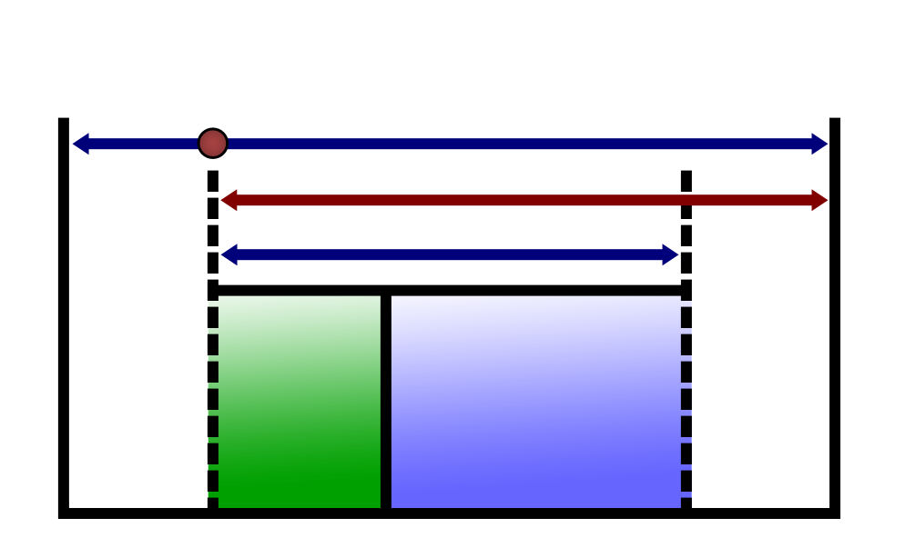
Terrorist task
complete
First alarm occurs
Terrorist task time
Delay
Physical protection system
Time required
Detect
Respond
Terrorist begins
action
Terrorist
interrupted
Terrorist neutralized
Alarm assessed

Time

For the security force to be successful:
- Detection (the first alarm), alarm assessment, and interruption should occur as soon as possible after the terrorist action begins — as early in the process (to the left on the time line) as possible.
- The security force must interrupt (and neutralize if necessary) the terrorist before the terrorist’s task is completed.

This Page Intentionally Left Blank.

M.L. Garcia. (2001). The Design and Evaluation of Physical Protection Systems. Boston: Butterworth-Heinemann, 58.

